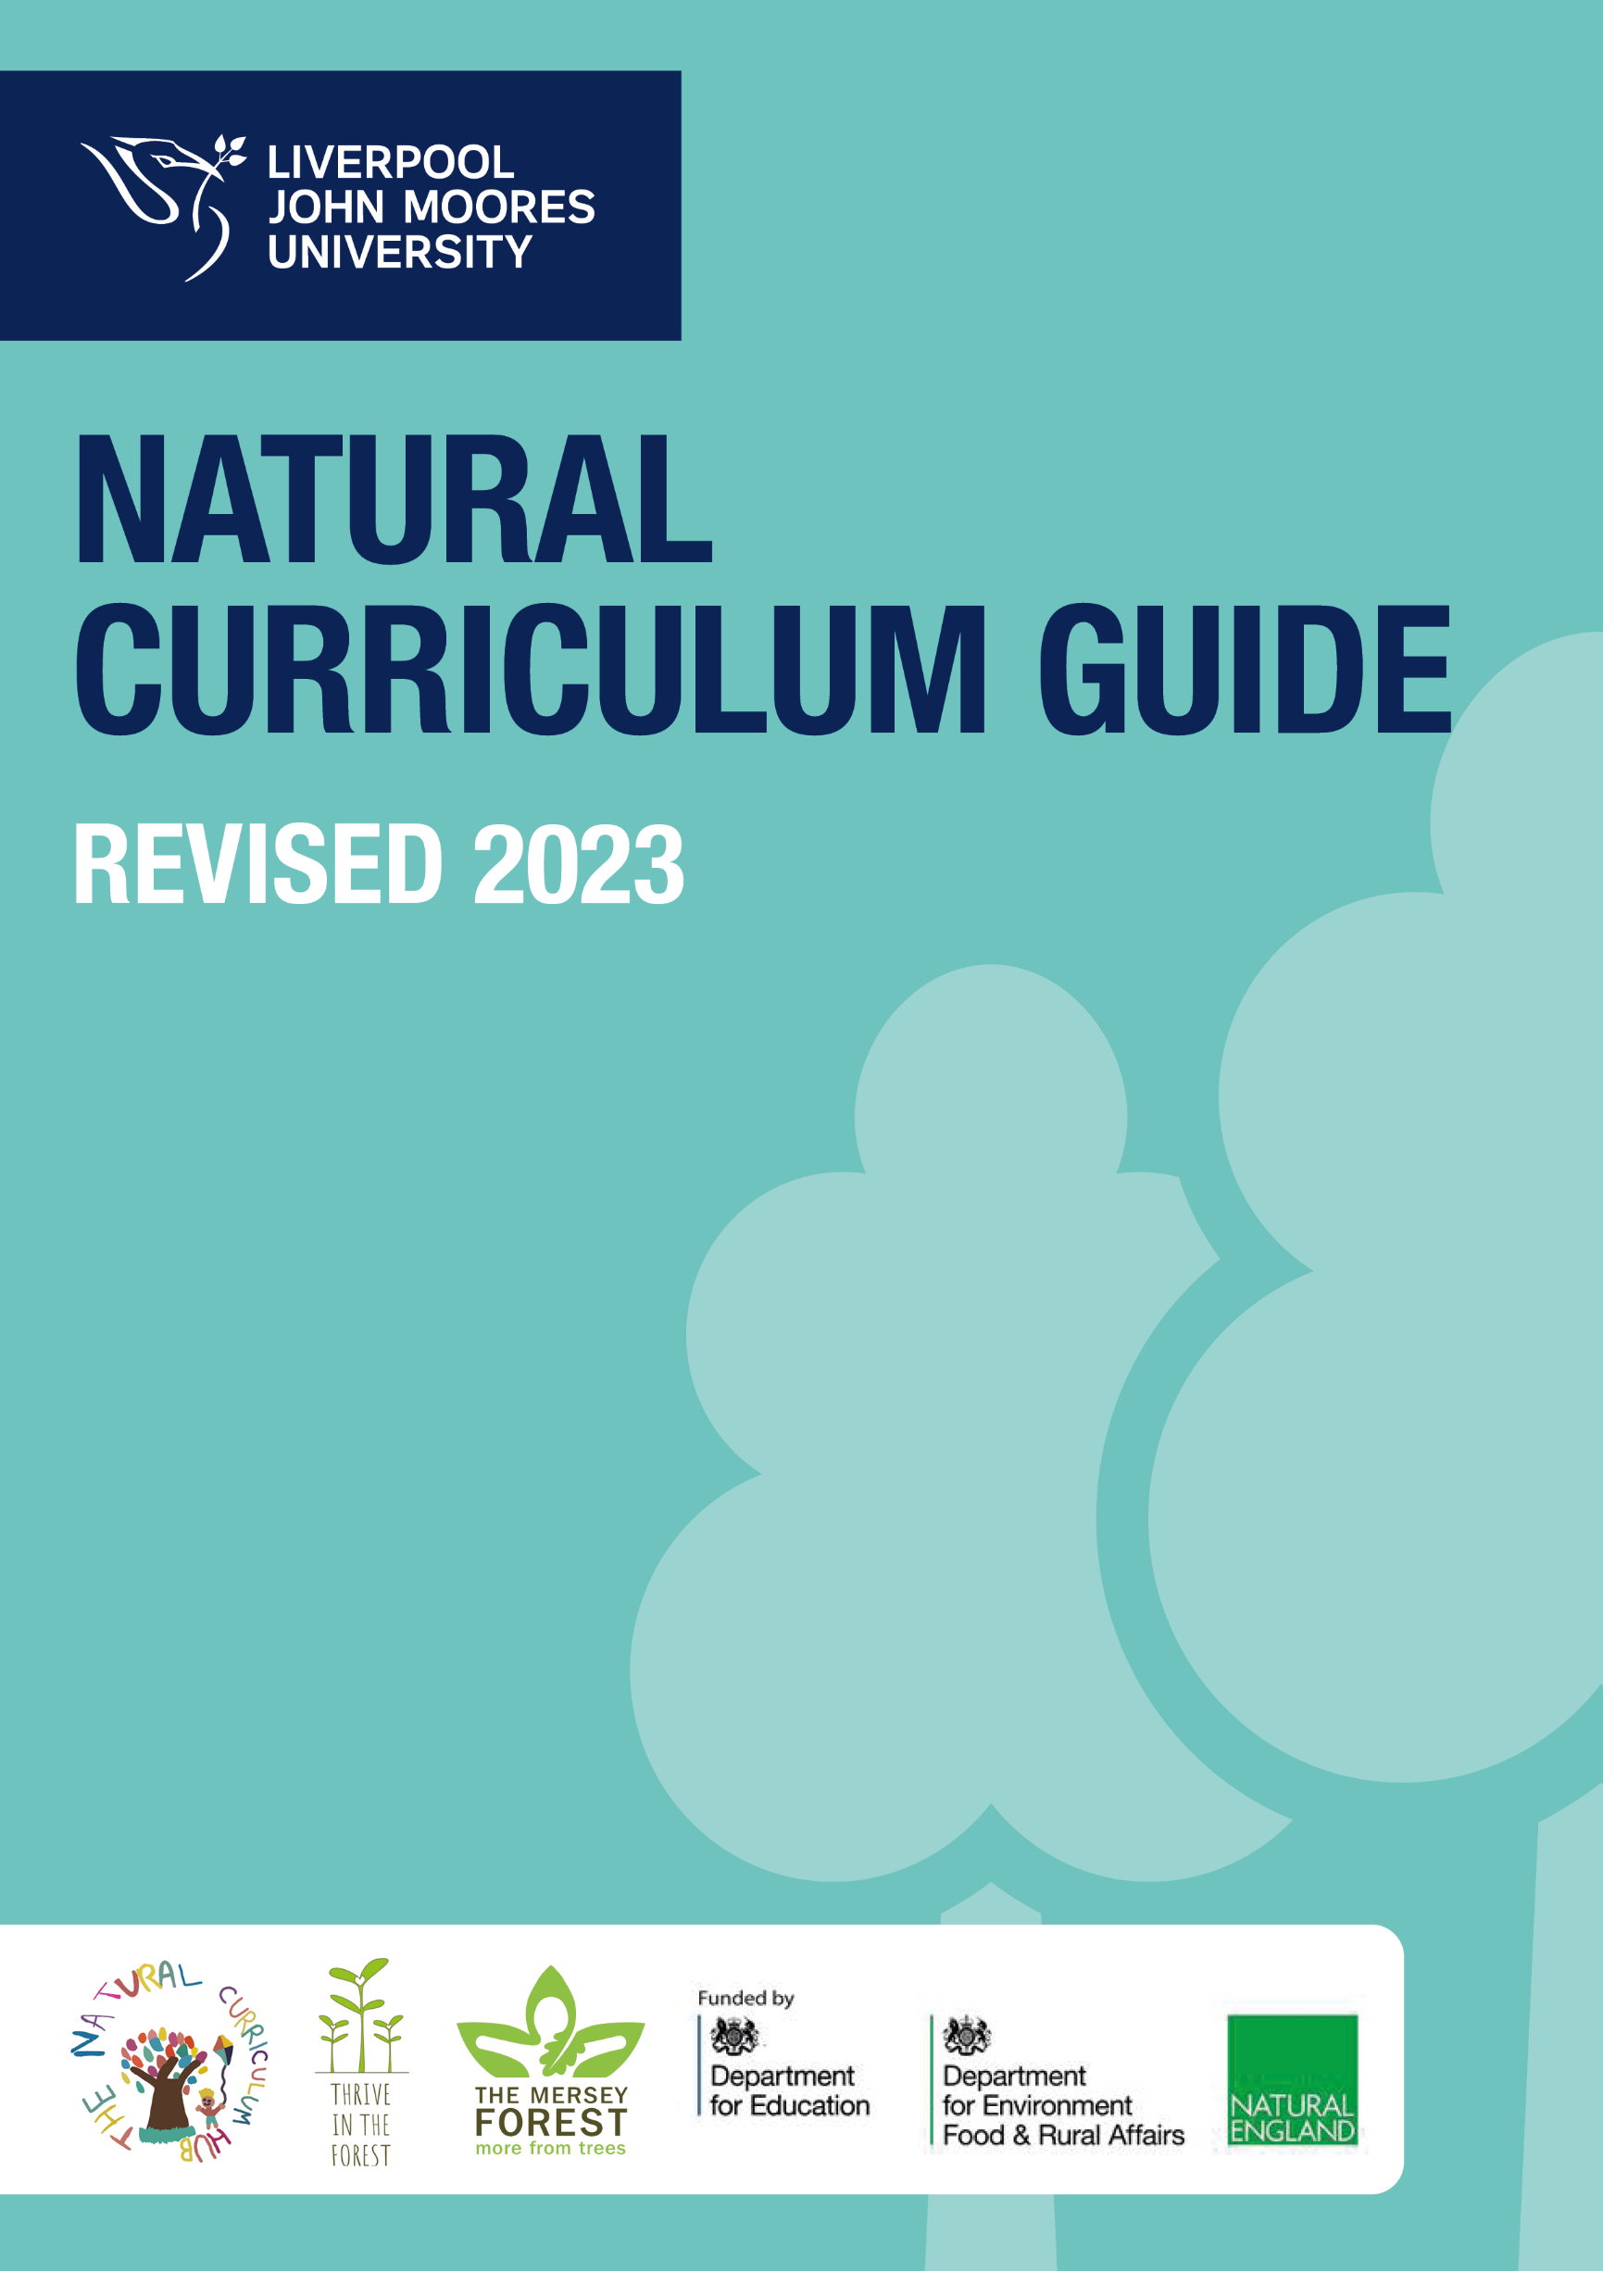
Revised 2025
ENGLISH

English in the Natural Curriculum Session Plan - KS1

Teacher: |  |  | Group/Class: |  | Number of pupils:
Title: Into the Forest - Anthony Browne | Number of sessions: 1 |  | Duration: 30 minutes
Age Range of Children: Year 2
Aims:
- I can use my knowledge of emotions and feelings to interpret and infer how the character in the book might be feeling.
- I can use my natural surroundings to inform my inferences
Links to National Curriculum:
Key Stage 1 |  |  |  | Key Stage 2
- Drawing on what they already know or on background information and vocabulary provided by the teacher
- Making inferences on the basis of what is being said and done

Prior Knowledge/Experience of group:
- The book should already have been read to the children and discussions around who the different children the little boy meets should have been discussed (Hansel and Gretel, Jack and the Beanstalk and Little Red Riding Hood links)
- Discussion around emotions and the words we use to describe emotions would be beneficial.
Adult Role: (step by step instructions, including planned questions):

Story Sack contents:

Characters to pin on trees
Match/lighter for fire (if deciding to include this)
Large marker pens
Emotion cards with vocab to support LA/SEN

- Pin the different characters to trees around the forest school area with space around them for children to write - ensure you have a black marker pen for children to use
- Take children outside to forest school/wooded area
- Explain to children that today, similar to the little boy, they are going to take the ‘short cut’ through the Forest
- As you walk with the children and re-read the story stop at each character tree corresponding to who the little boy meets in the book
- Ask the children how they feel in this moment
- Ask some other children to use the leaves/twigs around them or their voices to make the sounds the little boy might hear (the noise of the fire, the little girl crying etc)
- Ask the children how they might feel if they were the little boy, get children with good answers to write their idea on the paper around the character
- Ask the children what they should do if they feel like this (problem solving) should they continue to talk to the characters? Run away? Scream for help?
Optional:
- If possible – create a small fire with children asking them to collect sticks etc to assist you
- Model how to safely light a fire
- Now use this as a central focus to determine the feelings of the two children sat next to the fire (Hansel and Gretel). Why would they light this fire? How does the smell and the warmth make you feel? Has your opinion of the children changed?
- Model how to safely put out a fire

- Discuss the fact that we are aware of these characters (from other fairy tales) and discuss if it makes us feel any more relaxed/comfortable with them.
- Ask children if their emotions are different now they are with grandma compared to with the other characters
- When asking the children about the emotions they are feeling, ask them if they can show it through their body language
- Repeat this until all characters are finished
- Bring the character sheets into the classroom and encourage the use of the words brainstormed in the activity in their writing

Children’s Activity (Holistic learning and development):  - Speaking and listening  - Inference  - Social and emotional development  - Language and vocabulary development |  | AFL:  - Are children able to infer accurate feelings and emotions  - Do their physical depictions of emotions match the emotion they are trying to perform?  - Can children use a range of challenging vocabulary to express feelings and emotions?
Differentiation/Inclusion:
- TA to bring a dictionary and thesaurus to support LA and stretch HA
Children’s Self-esteem/Independence skills:
I can:
- Infer how a character is feeling by using a range of vocabulary
- Show how a character is feeling using body language and drama

English in the Natural Curriculum Session Plan – KS2

Teacher: |  |  | Group/Class: |  | Number of pupils:
Title: The Tunnel - Anthony Browne | Number of sessions: 1 |  | Duration: 30 minutes
Age Range of Children: Year 3
Aims:

- Children can create a small, functional structure inspired by the text, using materials around them
- Children can identify hidden characters/objects in illustrations, create them using natural materials and develop expanded noun phrases describing the character/object they have made using a thesaurus to extend.

Links to National Curriculum:
Key Stage 1 |  |  |  | Key Stage 2
- Expanded noun phrases
- Teaching should be directed more towards developing their vocabulary and the breadth and depth of their reading
Prior Knowledge/Experience of group:
- Teacher should have read text up to the little girl exiting the Tunnel
- Children should spend some time focusing on the trees in the background of pg.16 and 17.
- Identify the different animals they can see within the bark
- Demonstrate how to use a thesaurus
Adult Role: (step by step instructions, including planned questions):

Resources:
The Tunnel by Anthony Browne
Pictures of the animals/objects hidden in the trees and background (fox, owl, bear, giant thumb, axe, wolf, fire)
Whiteboard to model expanded noun phrases
Thesaurus to model extending vocabulary

1.
- Read the book up until the little girl exits the tunnel
- Take some time to discuss forest surroundings, are they similar to the text? How does it make you feel?
- What do you think the tunnel looks like? What's in the tunnel? What would the little girl be feeling? What is at the end of this tunnel?
2. (optional activity as material/adult supervision dependent)
- Explain to the children that you are going to make the tunnel that the characters crawl through
- Split class into two groups, one group to work with teacher the other to work with TA
- Ask children to find large branches and leaves to help create a tunnel
- Use fabric and material to help cover the tunnel
- Test out each other's tunnels and self/peer assess

3.
- Continue reading the text up to pg.16/17
- Assign a different animal/item that is camouflaged into the trees and background to each group of children (wolf, bear, pig, owl, giant thumb, fire)
- Ask children to work in groups to use the materials in their surroundings to create a nature art piece which depicts their animal/object
- Ask children to work together to come up with 2 expanded noun phrases using thesaurus to expand their vocabulary - if they have completed this with time to spare, ask children to create the noises of their object/animal using their voices/bodies/leaves/twigs around them
- Take children on a tour of each other’s work and listen to the expanded noun phrases
- Encourage peer feedback and marking

Children’s Activity (Holistic learning and development):  - Fine and gross motor skills  - Creativity  - Vocabulary and use of thesauruses  - Group work/social interaction |  | AFL:  - Can children develop expanded noun phrases which use extended vocabulary  - Can children accurately use thesauruses
Differentiation/Inclusion:
TA to work with SEN and LA.
Support children struggling to use thesauruses
Children’s Self-esteem/Independence skills:
I can:
- Use a thesaurus to extend my expanded noun phrases
- Use my environment to artistically represent characters in a book

English in the Natural Curriculum Session Plan - Phonics

Teacher: |  |  | Group/Class: Reception |  | Number of pupils:
Title: Tricky Words Hopscotch | Number of sessions: 1 |  | Duration: 30 minutes
Age Range of Children: Reception/KS1
Aims:
- To recognise a range of tricky words currently being studied in lessons
- To read a range of tricky words currently being studies in lessons
- To put a range of tricky words into a spoken sentence
Links to National Curriculum:
EYFS |  |  |  | Key Stage 1
prime areas of development:  - communication and language  - physical development  - personal, social and emotional development  Specific areas of development:  - communication and language |  |  |  | Spoken Language:  - listen and respond appropriately to adults and their peers  - use relevant strategies to build their vocabulary  - speak audibly and fluently with an increasing command of Standard English  Reading:  - read common exception words, noting unusual correspondences between spelling and sound and where these occur in the word  - discussing word meanings, linking new meanings to those already known  - drawing on what they already know or on background information and  - vocabulary provided by the teacher  - common exception words  Writing:  - write sentences by:  - saying out loud what they are going to write about  - composing a sentence orally before writing it  - sequencing sentences to form short narratives  - re-reading what they have written to check that it makes sense  - discuss what they have written with the teacher or other pupils  - read aloud their writing clearly enough to be heard by their peers and the teacher.
Prior Knowledge/Experience of group:
- Should have some knowledge of the tricky words.
- Should be able to put the words into sentences.
Adult Role: (step by step instructions, including planned questions):

- Teacher to set up the hopscotch areas on the playground.
- Write a tricky word in chalk into each square.
- Model the game to the pupils:
  - Read the tricky word in the first square.
  - Throw a small stone, twig, beanbag, or other marker into the word they have just read in the first square. (If it lands on a line, or outside the square, they lose their turn. Pass the marker to the following player and wait for their next turn.)
  - Hop on one foot into the first empty square, and then every subsequent empty square. Be sure to skip the one the marker is on.
  - At the pairs (4-5 and 7-8), jump with both feet.
  - At 10, hop with both feet, turn around, and head back toward the start.
  - When they reach the marked square again, pick up the marker—still on one foot! — and complete the course.
  - Construct a sentence with their partner which contains the tricky word from that turn. Write this onto a whiteboard.
  - If they finish without any mistakes, pass the marker to the next player. On their next turn, throw the marker to the next word.
  - If they fall, jump outside the lines, or miss a square or the marker, they lose their turn and must repeat the same number on their next turn. Whoever reaches the last word first, wins.
- Bring class back together to share and discuss the sentences written for each of the tricky words.

Children’s Activity (Holistic learning and development):  - Drawing on personal knowledge of the outdoors to respond to questions  - Developing gross motor skills  - Speaking and listening  - Wellbeing  - Behaviour |  | AFL:  - Are the children able to recognise the tricky words and read them to a partner?  - Are the children able to follow instructions and carry out the action without being distracted or needing further instructions?  - Children can make reasonable/sensible sentences with the tricky words.  - Peer assessment of sentences.
Differentiation/Inclusion:

Mixed ability pairings.
SEN or EAL - work with a TA or in a partner to support learning.

Children’s Self-esteem/Independence skills:
I can:
- Read tricky words
- Put tricky words into sentences

English in the Natural Curriculum Session Plan – KS 2

Teacher: |  |  | Group/Class: |  | Number of pupils:
Title: Persuasive Writing – Opposing Council Land Development | Number of sessions: 1 |  | Duration: 30 minutes
Age Range of Children: UKS2
Aims:
- To recognise a range of tricky words currently being studies in lessons
- To read a range of tricky words currently being studies in lessons
- To put a range of tricky words into a spoken sentence
Links to National Curriculum:
Key Stage 1 |  |  |  | Key Stage 2
Spoken Language:
- listen and respond appropriately to adults and their peers
- ask relevant questions to extend their understanding and knowledge
- maintain attention and participate actively in collaborative conversations, staying on topic and initiating and responding to comments
- use spoken language to develop understanding through speculating, hypothesising, imagining and exploring ideas
- use relevant strategies to build their vocabulary
- speak audibly and fluently with an increasing command of Standard English
- participate in discussions, presentations, performances, role play, improvisations and debates
Reading:
- continuing to read and discuss an increasingly wide range of fiction, poetry,
- plays, non-fiction and reference books or textbooks
- reading books that are structured in different ways and reading for a range of purposes
- asking questions to improve their understanding
- drawing inferences such as inferring characters’ feelings, thoughts and motives
- from their actions, and justifying inferences with evidence
- distinguish between statements of fact and opinion
- explain and discuss their understanding of what they have read, including through
- formal presentations and debates, maintaining a focus on the topic and using notes
- where necessary
- provide reasoned justifications for their views.

Writing:
- plan their writing by:
  - identifying the audience for and purpose of the writing, selecting the appropriate
  - form and using other similar writing as models for their own
  - noting and developing initial ideas, drawing on reading and research where necessary
- discuss what they have written with the teacher or other pupils
read aloud their writing clearly enough to be heard by their peers and the teacher.
- develop their understanding of the concepts set out in English Appendix 2 by:
  - recognising vocabulary and structures that are appropriate for formal speech and writing, including subjunctive forms
  - using passive verbs to affect the presentation of information in a sentence
Prior Knowledge/Experience of group:
- Should have some knowledge of persuasive writing
- Should be able to put the words into sentences.
Adult Role: (step by step instructions, including planned questions):

- Teacher to read out the letter from Grab It Land Development Ltd.
- Pupils to discuss with their partner what they think of the contents of the letter:
  - Do they agree with it?
  - Who would be the most affected by the decision to build on the land?
  - What are the positive aspects of the development?
  - What are the negative aspects of the development?
- Put the children into pairs/groups to discuss the views of the groups most affected by the land development and assign each group/pair a specific group.
- Allow enough time for them to put together a statement which best represents the view of their specific group of people.
- Each group in turn to present their statement to the rest of the class.
- Who was the most convincing?
- Vote on the most convincing statement – why was it convincing?
- Extension could be to write an extended piece of persuasive writing from the perspective of the different groups affected by the development.
Children’s Activity (Holistic learning and development):  - Drawing on personal knowledge of the sustainability to respond to questions  - Speaking and listening  - Wellbeing  - Behaviour |  | AFL:  - Are the children able to discuss their ideas with a partner?  - Are the children able to follow instructions and carry out the action without being distracted or needing further instructions?  - Children can make reasonable/sensible arguments for and against the land development.
Differentiation/Inclusion:

Mixed ability pairings.
SEN or EAL - work with a TA or in a partner to support learning.

Children’s Self-esteem/Independence skills:
I can:
- Discuss ideas with my peers
- I can present my ideas to a group

English in the Natural Curriculum Session Plan - KS2

Teacher: |  |  | Group/Class: |  | Number of pupils:
Title: Poetry – Outdoor Haiku poems | Number of sessions: 1 |  | Duration: 30 minutes
Age Range of Children: UKS2
Aims:
- To recognise the features of a Haiku poem and its origins (SK: A haiku is an unrhymed Japanese poetic form that consists of 17 syllables arranged in three lines containing five, seven, and five syllables, respectively. A haiku expresses much and suggests more in the fewest possible words).
- To listen to the sounds around them to develop vocabulary for haiku poetry
- Write a haiku poem about the outdoors
- Read their haiku poem to a partner and/or the class
Links to National Curriculum:
Key Stage 1 |  |  |  | Key Stage 2
Spoken Language:
- listen and respond appropriately to adults and their peers
- ask relevant questions to extend their understanding and knowledge
- maintain attention and participate actively in collaborative conversations, staying on topic and initiating and responding to comments
- use spoken language to develop understanding through speculating, hypothesising, imagining and exploring ideas
- use relevant strategies to build their vocabulary
- speak audibly and fluently with an increasing command of Standard English
- participate in discussions, presentations, performances, role play, improvisations and debates
Reading:
- continuing to read and discuss an increasingly wide range of fiction, poetry,
- plays, non-fiction and reference books or textbooks
- reading books that are structured in different ways and reading for a range of purposes
- asking questions to improve their understanding

Writing:
- plan their writing by:
  - identifying the audience for and purpose of the writing, selecting the appropriate
  - form and using other similar writing as models for their own
- discuss what they have written with the teacher or other pupils
read aloud their writing clearly enough to be heard by their peers and the teacher.
- develop their understanding of the concepts set out in English Appendix 2 by:
  - recognising vocabulary and structures that are appropriate for formal speech and writing, including subjunctive forms
  - using passive verbs to affect the presentation of information in a sentence
Prior Knowledge/Experience of group:
- Should have some knowledge of persuasive writing
- Should be able to put the words into sentences.
Adult Role: (step by step instructions, including planned questions):

- Teacher to read out the Haiku poem examples:

The wind did not blow
And the grass was not stirring
So then it was peace

The smooth pillow grass
And the pureness of the air
Was a perfect mix

The silence was soft
The burning sun beat down hard
While we were writing

With the day ahead
Just waiting to unfold now
I thought to myself

- What do they notice? (ie line 1 = 5 syllables, line 2 = 7 syllables, line 3 = 5 syllables)
- What sort of language is used? Any rhyming?
- Give each child a wipeboard and pen and ask them to go to a space in the area and sit quietly, with eyes closed, listening to the sounds around them.
- Write some adjectives to describe the sounds they have heard.
- Use this word bank to write a Haiku poem about the outdoors.
- Read their Haiku poem to a partner. Give peer feedback and make improvements if necessary.
- Ask for volunteers to read their Haiku poem to the rest of the class.
Children’s Activity (Holistic learning and development):  - Drawing on personal knowledge of the environment and vocabulary to describe it  - Speaking and listening  - Wellbeing  - Behaviour |  | AFL:  - Are the children able to read their poem a partner and give peer feedback?  - Are the children able to follow instructions and carry out the action without being distracted or needing further instructions?  - Are they able to write a Haiku poem.
Differentiation/Inclusion:

Mixed ability pairings.
SEN or EAL - work with a TA or in a partner to support learning.

Children’s Self-esteem/Independence skills:
I can:
- Write a Haiku poem
- Discuss ideas with my peers
- I can present my ideas to a group

Story Sacks

What is a Story Sack?

A story sack is a themed collection of resources designed to support storytelling. Typically contained in a large bag or pillowcase, it includes a picture book or oral story as the central focus, accompanied by props and activities that encourage exploration and participation.

Common items in a story sack include:

Picture books and factual books

Soft toys and puppets

Backdrops and props

Costumes and accessories

Musical instruments

Audio recordings

Games and sensory objects

Activity booklets and discussion cards

Where can I find a Story Sack?

The National Literacy Trust provides a free, downloadable guide with step-by-step instructions for making story sacks. This guide includes examples based on The Three Little Pigs and We’re Going on a Bear Hunt. Access it here: www.literacytrust.org.uk/assets/0000/3210/Story_sack_guide.pdf.

Pinterest is another excellent resource for inspiration. Searching for terms such as ‘story sack,’ ‘story bag,’ ‘story box,’ or ‘sensory tub’ will provide a wide range of creative ideas. Explore more here: https://uk.pinterest.com/renitaboyle/story-bags-boxes-baskets-tubs/.

For those who prefer ready-made options, companies such as Storysack® offer pre-assembled story sacks. Many schools and libraries already have access to these, and some provide loan schemes for teachers. You can explore more at www.storysack.com.

How can I use a Story Sack?
Once you have created, purchased or borrowed a story sack, it is important to prepare for its use effectively. Here are five key steps to consider:
- Know Your Class, Setting, and Timeframe
Consider the age group, learning abilities and classroom environment. Will this be a one-time session or part of an ongoing storytelling routine?
- Assess Your Own Storytelling Strengths
Think about your comfort level with storytelling techniques and plan accordingly. Consider practical needs such as seating arrangements, voice projection and strategies to manage engagement.
- Plan the Session Structure
A well-structured storytelling session helps maintain students' focus and maximises learning. Common session components include:
  - Warm-up activity (craft/game/music)
  - Introductory song or tongue twister
  - Picture book storytelling with props
  - Hands-on activity or craft
  - Oral storytelling session
  - Wrap-up song and discussion
- Explore the Story Sack Contents in Advance
Familiarise yourself with the items in the story sack and plan how to use them. Consider whether any activities need adaptation to suit your students’ needs.
- Practice Storytelling Techniques
Read the story multiple times and rehearse your delivery. Use varied tones, pacing and volume to create an engaging experience. Encourage student participation by using repeated phrases, character voices and interactive elements.

Additional Ideas to Make the Most of Your Story Sack

- Incorporate oral storytelling: If the story sack does not include a traditional oral story, consider adding one. Eye-to-eye storytelling without a book enhances creativity and connection.
- Use factual books for cross-curricular links: Tie in elements of science, history or geography by exploring real-world themes related to the story.
- Encourage student-led discussions: Use open-ended questions to promote critical thinking, such as:
  - What did you like best about the story?
  - If you were a character in the story, who would you be?
  - Would you change anything about the story?
  - How did the story make you feel?
  - Can you retell the story in your own words?
- Include hands-on activities: Plan simple crafts or role-playing exercises to reinforce learning. Keep a basic craft kit ready for quick and easy setup.
- Enhance the experience with additional elements:
  - Introduce a classroom mascot (a puppet or toy) to support storytelling.
  - Incorporate movement-based activities such as parachute games or action songs.
  - Provide time for students to explore the story sack independently, encouraging them to retell the story to one another.
  - Gathering activity/craft/game.
  - Settle in action song or tongue twister.
  - Story sack picture book with props.
  - Craft.
  - Story sack factual book activity.
  - Oral story.
  - Goodbye song.

Explore the contents of your story sack for yourself.

Although story sacks can be used right off the peg with minimal preparation, this is not the most effective thing to do. Your goal is to use the contents of the story sack to create the best possible experience for those attending your session. Make some time well in advance to explore what is in the sack for yourself: take everything out and have a good look at it.

Play with it and have a go, become familiar with what is there. Make sure to read any suggestions contained in the bag for how to use it. Think about your group and how they might respond to what is in front of you: which activities will be most suitable for them? Which will need adapting? Which will you leave out? What will you need to add in - an oral story, tongue twister, song, parachute game, craft, poem, etc.?

Read the picture book for yourself and practice how you will tell it as a story.

Your story sack will contain an engagingly written, beautifully illustrated picture book. It is also likely to contain props or a backdrop for helping you to tell it. These are often puppets, soft toys or simple objects.

Read the picture book until you become familiar with it but remember that it is essentially a well-told story. Look for ways in which you can engage your group in telling it with you. Try giving each character a different voice or find a repetitive phrase within the text that you can all say together. Use eye contact, pauses, change of tone, pace and volume. Create suspense, tension and resolution in the way you tell it.

Try to resist the temptation to simply hold the book up for all to see and read it aloud. Instead, engage as much as possible with the objects given. Preparation will bring confidence and give you the opportunity to work out any kinks or difficulties. Think about how you will reveal the characters and backdrop. Will you keep them out of sight until needed? Think about how you can help volunteers from the group to re-tell this story to their peers.

Prepare an oral story - no books.

Your bag may or may not contain a suggestion for a traditionally told oral story - one that is told without the aid of a book. If a suggestion is not included, try to add your own to the mix.

You will find excellent storytelling resources and workshops via the Scottish Storytelling Centre. Here, for example, is a free, downloadable Early Years Starter Pack ideal for use with story sacks. www.tracscotland.org/sites/default/files/10-earlyyearsstarter.pdf

- Use facts from the fact book.

Take some to think through how you will best use a fact book during your session. Guidance or ideas may already be included for consideration in a ready to use story sack. If not, choose some pertinent or interesting facts from the book and use them creatively. Simple quizzes, colouring sheets or art projects work well. Use the fact book to find out more about the people or places in the picture book or oral story.

Encourage discussion - ask searching questions.

Your bag may contain a set of questions or a card of discussion starters to use with the story. If not, create a set of your own. Ask searching questions, you will be surprised how much a well-framed question will inspire. I often use these:
  - I wonder what part of the story you liked best?
  - I wonder who you were in the story?
  - I wonder if there is anything you would change about the story?
  - I wonder how you felt during the story?
  - I wonder what you will remember about that story when we go from here?
  - I wonder if you could tell that story?

Using crafts to support.

Include a simple craft in your session. Think through the materials and space you will need for whatever it is you choose to do. This is made much simpler if you create a kit of basics that is ready to go when you are. This could include scissors, glue sticks, colouring pencils, crayons, markers, water-colour pencils, paint brushes, plastic place mats and baby wipes.

Enhance your session – add in the ‘extras’.

There are many things that you will not find in a story sack that would exponentially increase the enjoyment and flow for all concerned. These might include:

  - Introducing a ‘mascot friend’: a puppet or pair of puppets or a few soft toys that are not part of the story sack. They will, however, become part of your group. They can be part of the ‘hello’ and ‘goodbye’, children can hold on to them during the story, include them in activities, tell jokes to them.

  - Having a few active games and energy busters ready to go. Parachutes are fantastic tools to have: they provide a natural shape for circle time and immediately create a sense of co- operative play and group belonging. It is amazing what you can do with a parachute or piece of lycra even in the confined space of a classroom or library.

  - Including songs: Silly songs or campfire favourites are hugely popular. They lend themselves to participation and are naturally full of many of things that make storytelling so enjoyable: rhythm, repetition and rhyme.

  - Allow some time to play. Let the group explore the contents of the story sack for themselves, encourage them to re-tell the stories to one another. Encourage them to explore long after the session is over.

English in the Natural Curriculum Session Plan- Story Sack Year 1

Teacher: |  |  | Group/Class: |  | Number of pupils:
Title: The Gruffalo by Julia Donaldson | Number of sessions: 1 |  | Duration: 1 hour and a half
Age Range of Children: Year 1
Aims:
- Children can retell parts of the story through reading out loud and using natural materials to create illustrations.
Links to Natural Curriculum:
Key Stage 1 |  |  |  | Key Stage 2
National Curriculum -
- Participate in discussion about what is read to them, taking turns and listening to what others say
- Becoming very familiar with key stories, fairy stories and traditional tales, retelling them and considering their particular characteristics

Prior Knowledge/Experience of group:
- Children should be familiar with the story
- Children should be grouped with children they work well with
Adult Role: (step by step instructions, including planned questions):

Story Sack contents:

The Gruffalo by Julia Donaldson book
Animal character cards - use cuddly toys if available (mouse, fox, owl, snake, Gruffalo)
Different sections of the book printed for children (Provided in resources)
Sticks, twigs, rocks, leaves etc

- Take children into forest school/wooded area available
- Organise children into a circle with teacher at the central focus
- Start to read the book, pausing at different sections that describe the location (underground house, treetop house, deep dark wood), ask children if they have ever been anywhere like that before, ask them how they felt.
- Ensure you share the illustrations with the children
- Split children into groups of 3/4 and give them a section of the story
- Ask children to use the materials in their surroundings to create/recreate a ‘nature art’ to describe what is happening in their piece of text (Children might create the fox’s underground hut or the Gruffalo’s orange eyes)
- Once children have finished creating their nature art go on a tour with the children to each group
- Ask the group to read their section of the story and discuss the art they have created, why they created it, how they created it and what they used.

Children’s Activity (Holistic learning and development):  - Development of gross and fine motor skills  - Reading comprehension and word recognition  - Group work  - Creativity |  | AFL:  - Children are able to work together and encourage the other children in the group to participate  - Children can create a picture/art piece using the materials in their surroundings to re-tell their part of the story
Differentiation/Inclusion:

TA to work with SEN/children who struggle with decoding to enable them to access the piece of text

Children’s Self-esteem/Independence skills:
I can:
- Work with my peers to create a piece of artwork
- I can listen, read and interpret a piece of text to inform my decisions when creating a piece of art

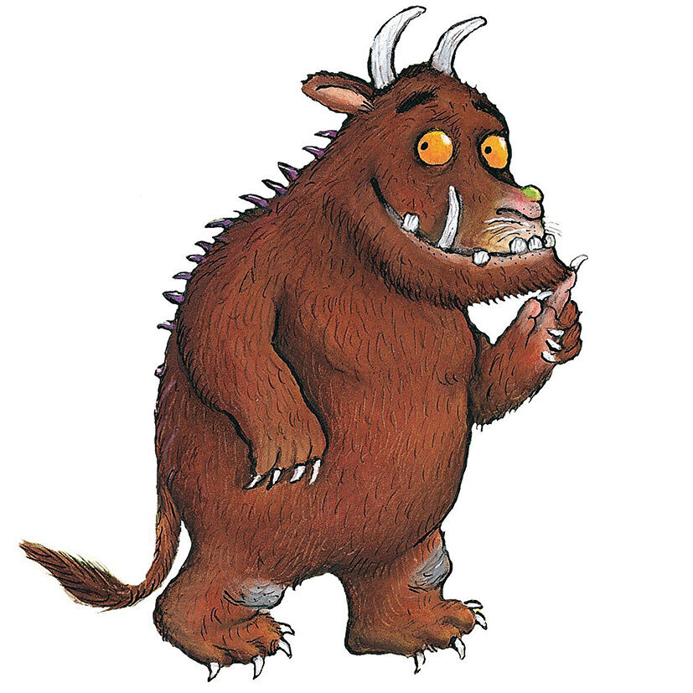

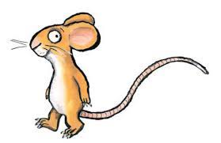

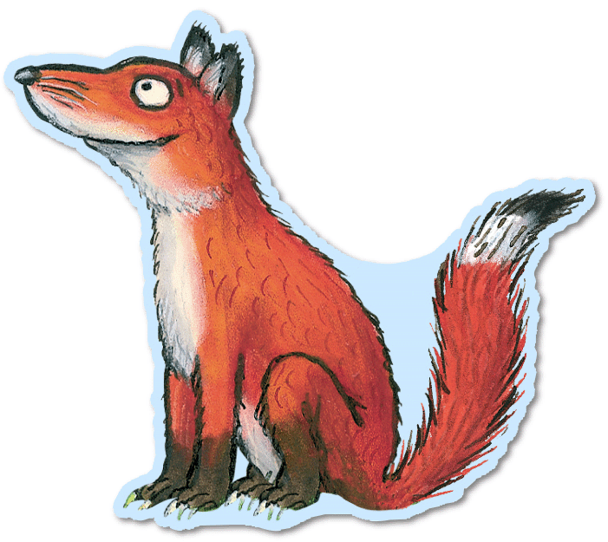

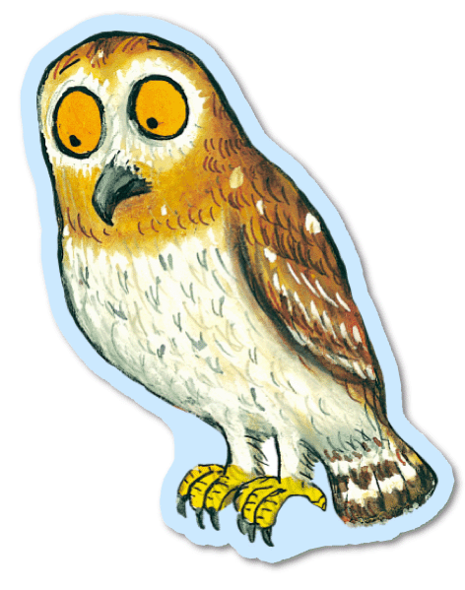


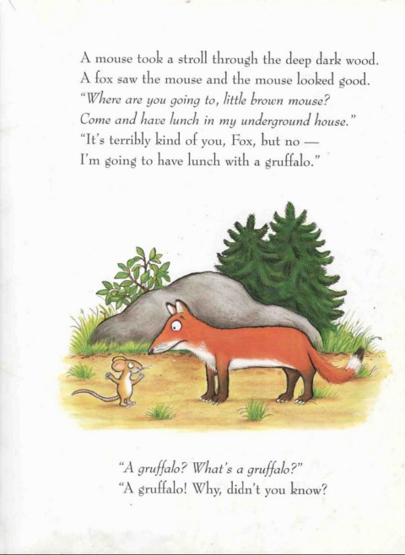

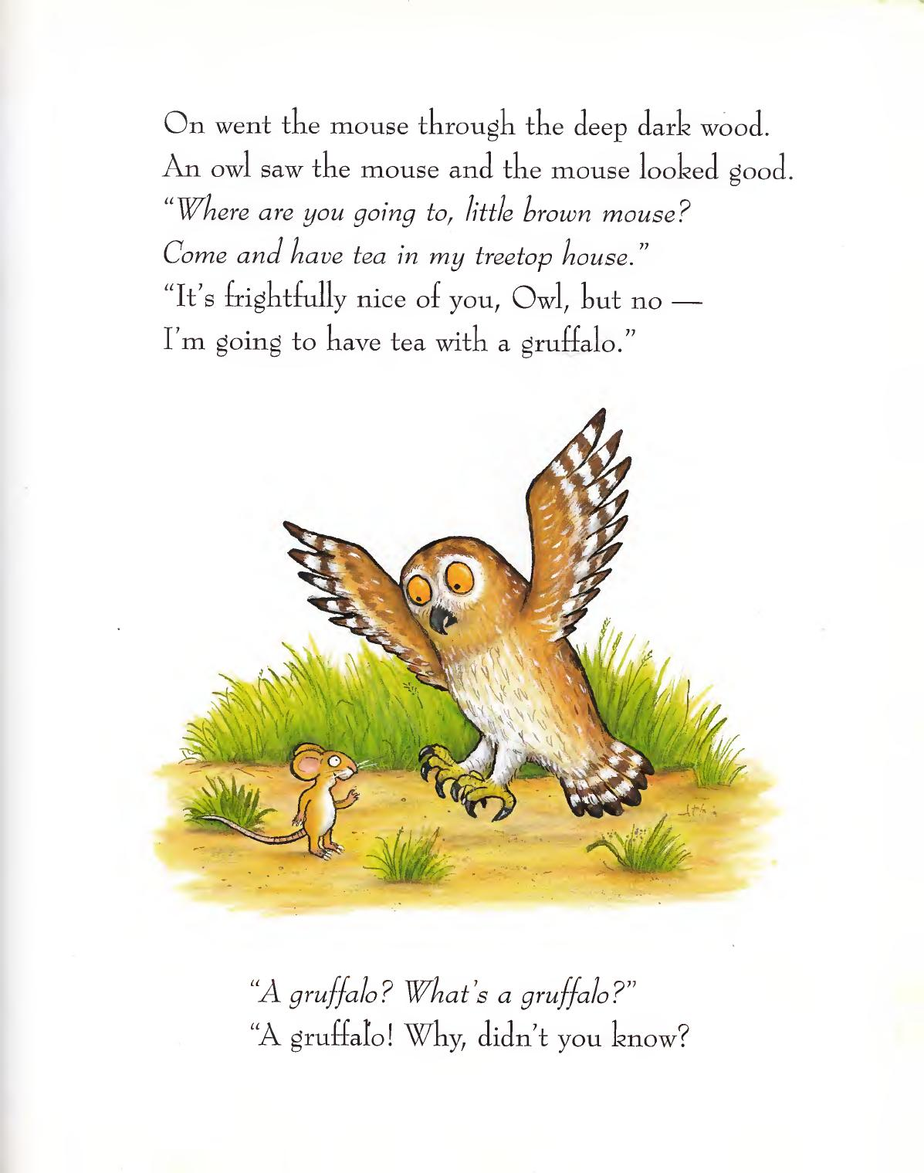

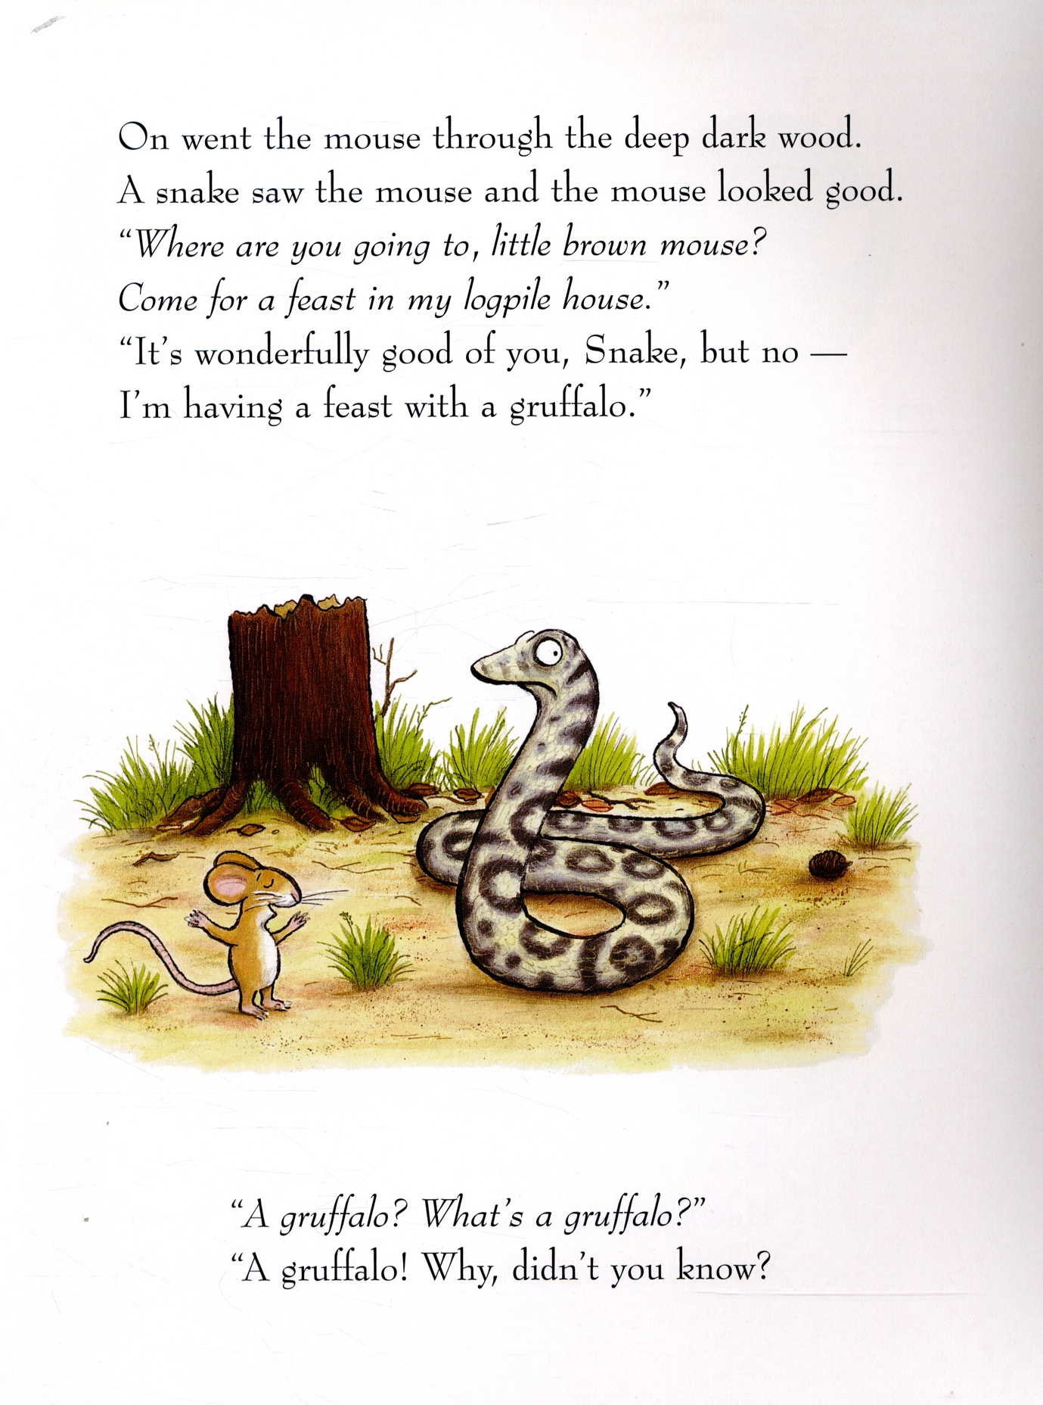

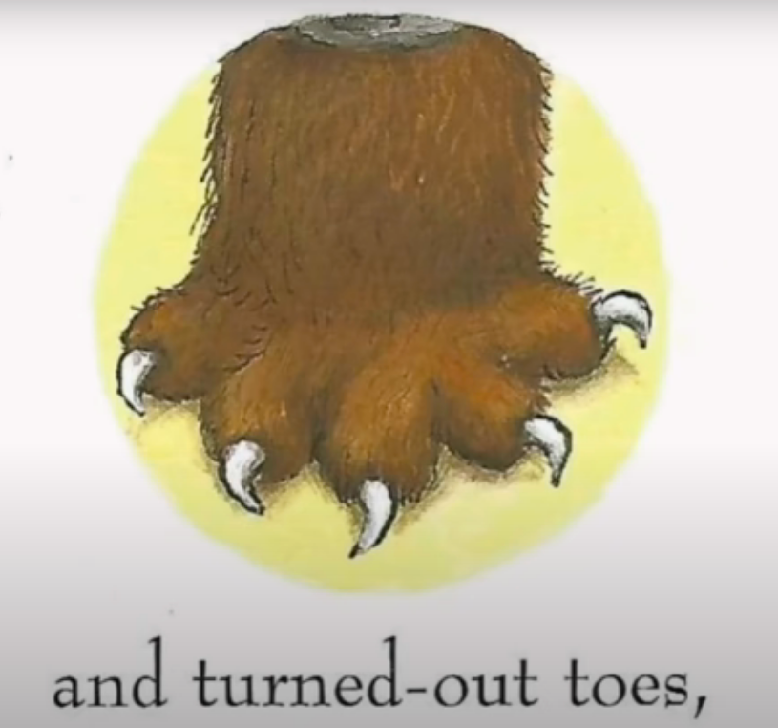

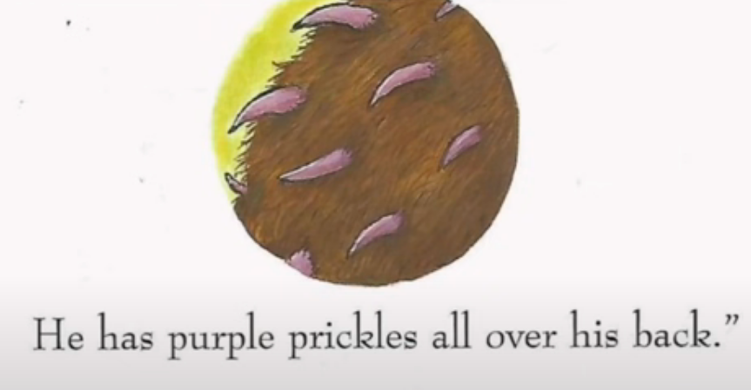

v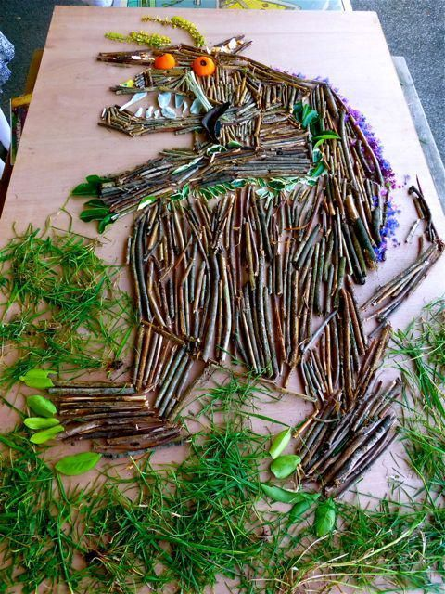

English in the Natural Curriculum Session Plan – Story Sack Year 2

Teacher: |  |  | Group/Class: Year 2 |  | Number of pupils:
Title: Into the Forest - Anthony Browne | Number of sessions: 1 |  | Duration: 30 minutes
Age Range of Children: Year 2
Aims:
- I can use my knowledge of emotions and feelings to interpret and infer how the character in the book might be feeling.
- I can use my natural surroundings to inform my inferences
Links to National Curriculum:
Key Stage 1 |  |  |  | Key Stage 2
- Drawing on what they already know or on background information and vocabulary provided by the teacher
- Making inferences on the basis of what is being said and done

Prior Knowledge/Experience of group:
- The book should already have been read to the children and discussions around who the different children the little boy meets should have been discussed (Hansel and Gretel, Jack and the Beanstalk and Little Red Riding Hood links)
- Discussion around emotions and the words we use to describe emotions would be beneficial.
Adult Role: (step by step instructions, including planned questions):

Story Sack contents:

Characters to pin on trees
Match/lighter for fire (if deciding to include this)
Large marker pens
Emotion cards with vocab to support LA/SEN

- Pin the different characters to trees around the forest school area with space around them for children to write - ensure you have a black marker pen for children to use
- Take children outside to forest school/wooded area
- Explain to children that today, similar to the little boy, they are going to take the ‘short cut’ through the Forest
- As you walk with the children and re-read the story stop at each character tree corresponding to who the little boy meets in the book
- Ask the children how they feel in this moment
- Ask some other children to use the leaves/twigs around them or their voices to make the sounds the little boy might hear (the noise of the fire, the little girl crying etc)
- Ask the children how they might feel if they were the little boy, get children with good answers to write their idea on the paper around the character
- Ask the children what they should do if they feel like this (problem solving) should they continue to talk to the characters? Run away? Scream for help?
Optional:
- If possible – create a small fire with children asking them to collect sticks etc to assist you
- Model how to safely light a fire
- Now use this as a central focus to determine the feelings of the two children sat next to the fire (Hansel and Gretel). Why would they light this fire? How does the smell and the warmth make you feel? Has your opinion of the children changed?
- Model how to safely put out a fire

- Discuss the fact that we are aware of these characters (from other fairy tales) and discuss if it makes us feel any more relaxed/comfortable with them.
- Ask children if their emotions are different now they are with grandma compared to with the other characters
- When asking the children about the emotions they are feeling, ask them if they can show it through their body language
- Repeat this until all characters are finished
- Bring the character sheets into the classroom and encourage the use of the words brainstormed in the activity in their writing

Children’s Activity (Holistic learning and development):  - Speaking and listening  - Inference  - Social and emotional development  - Language and vocabulary development |  | AFL:  - Are children able to infer accurate feelings and emotions  - Do their physical depictions of emotions match the emotion they are trying to perform?  - Can children use a range of challenging vocabulary to express feelings and emotions?
Differentiation/Inclusion:
- TA to bring a dictionary and thesaurus to support LA and stretch HA
Children’s Self-esteem/Independence skills:
I can:
- Infer how a character is feeling by using a range of vocabulary
- Show how a character is feeling using body language and drama

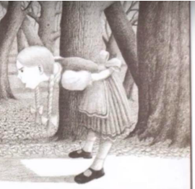

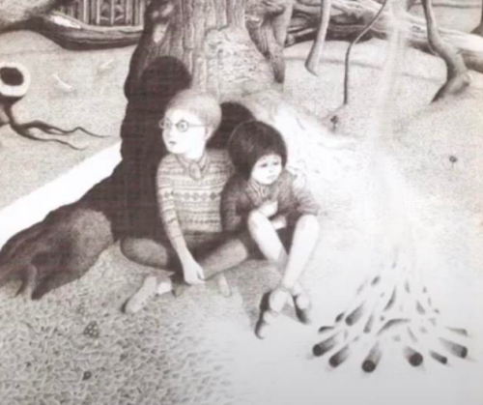

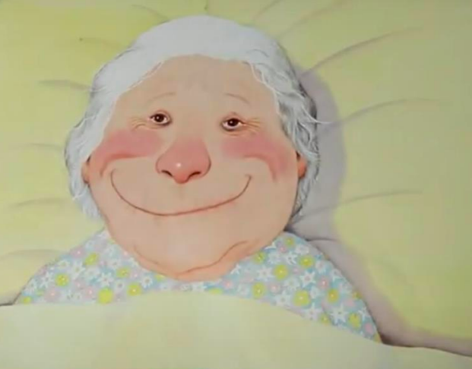
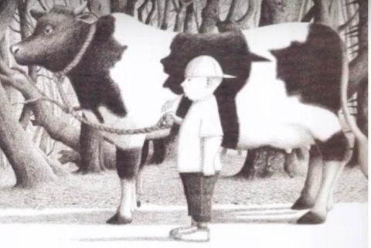

English in the Natural Curriculum Session Plan – Story Sack Year 3
Teacher: |  |  | Group/Class: |  | Number of pupils:
Title: The Tunnel - Anthony Browne | Number of sessions: 1 |  | Duration: 1 hour and a half
Age Range of Children: Year 3
Aims:

- Children can create a small, functional structure inspired by the text, using materials around them
- Children can identify hidden characters/objects in illustrations, create them using natural materials and develop expanded noun phrases describing the character/object they have made using a thesaurus to extend.

Links to National Curriculum:
Key Stage 1 |  |  |  | Key Stage 2
- Expanded noun phrases
- Teaching should be directed more towards developing their vocabulary and the breadth and depth of their reading
Prior Knowledge/Experience of group:
- Teacher should have read text up to the little girl exiting the Tunnel
- Children should spend some time focusing on the trees in the background of pg.16 and 17.
- Identify the different animals they can see within the bark
- Demonstrate how to use a thesaurus
Adult Role: (step by step instructions, including planned questions):

Story sack contents:
The Tunnel by Anthony Browne
Pictures of the animals/objects hidden in the trees and background (fox, owl, bear, giant thumb, axe, wolf, fire)
Whiteboard to model expanded noun phrases
Thesaurus to model extending vocabulary

1.
- Read the book up until the little girl exits the tunnel
- Take some time to discuss forest surroundings, are they similar to the text? How does it make you feel?
- What do you think the tunnel looks like? What's in the tunnel? What would the little girl be feeling? What is at the end of this tunnel?
2. (optional activity as material/adult supervision dependent)
- Explain to the children that you are going to make the tunnel that the characters crawl through
- Split class into two groups, one group to work with teacher the other to work with TA
- Ask children to find large branches and leaves to help create a tunnel
- Use fabric and material to help cover the tunnel
- Test out each other's tunnels and self/peer assess

3.
- Continue reading the text up to pg.16/17
- Assign a different animal/item that is camouflaged into the trees and background to each group of children (wolf, bear, pig, owl, giant thumb, fire)
- Ask children to work in groups to use the materials in their surroundings to create a nature art piece which depicts their animal/object
- Ask children to work together to come up with 2 expanded noun phrases using thesaurus to expand their vocabulary - if they have completed this with time to spare, ask children to create the noises of their object/animal using their voices/bodies/leaves/twigs around them
- Take children on a tour of each other’s work and listen to the expanded noun phrases
- Encourage peer feedback and marking

Children’s Activity (Holistic learning and development):  - Fine and gross motor skills  - Creativity  - Vocabulary and use of thesauruses  - Group work/social interaction |  | AFL:  - Can children develop expanded noun phrases which use extended vocabulary  - Can children accurately use thesauruses
Differentiation/Inclusion:
TA to work with SEN and LA.
Support children struggling to use thesauruses
Children’s Self-esteem/Independence skills:
I can:
- Use a thesaurus to extend my expanded noun phrases
- Use my environment to artistically represent characters in a book

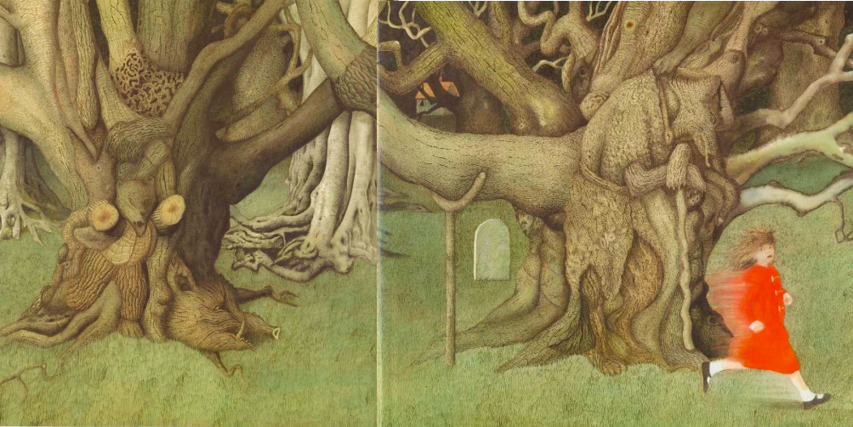

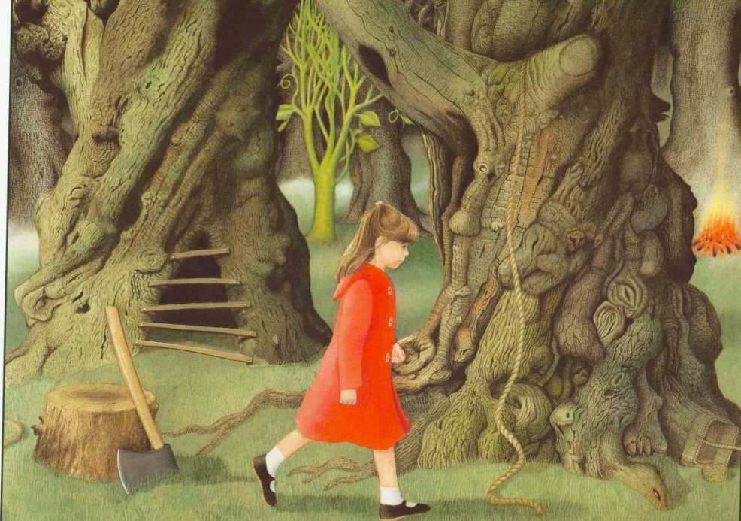
English in the Natural Curriculum Session Plan - Story Sack Year 4

Teacher: |  |  | Group/Class: |  | Number of pupils:
Title: There’s a Werewolf in my Tent | Number of sessions: 1 |  | Duration: 1 hour and a half
Age Range of Children: Year 4
Aims:
- I can work with a group to build a structure inspired by the text which will help inform my writing
- I can use my natural surroundings to empathise with characters and make predictions/inferences
Links to National Curriculum:
Key Stage 1 |  |  |  | Key Stage 2
National curriculum link
- planning writing by discussing and recording ideas

Prior Knowledge/Experience of group:
- Children should have some knowledge of instructional writing and the features evident in this style of text
- Plan to deliver a lesson were children use this experience to inform a ‘how to build an outdoor shelter’
Adult Role: (step by step instructions, including planned questions):

Story sack contents:

- ‘There's a werewolf in my tent’ book
- Marshmallows
- Camping accessories to ‘set the scene’
- Natural materials to assist building the structure and or fire

- ‘There's a werewolf in my tent’ is the preferred text as it creates the idea of a school camping trip, however, books that are available to you that include the theme of an outdoor structure/camping trip would also be suitable
- Read to children outside
- Tell children that they will be working in groups to create a structure which would be suitable to stay overnight in
- Brainstorm as a group the necessary ‘non-negotiables’ that the structure must have (waterproof/werewolf proof/size/cosy)
- Encourage the use of instructional vocab (imperative verbs, clear statements)
- Children to build structures
- Once finished go to each structure have children discuss how it was made and why they made certain design decisions
- Ensure children peer evaluate and self-evaluate, discussing what went well and what they could change
- Use this activity to inform an instructional piece of writing back in the classroom
Optional activity:

- As the shelters are built, to continue the theme of camping in the wilderness demonstrate how to build a fire and use sticks to toast marshmallows similar to the children from ‘There's a werewolf in my tent’ (contextual learning).
- Ask the children how the characters may feel doing this, does it make them feel cosy? Homesick? Introduce the idea of foreboding or a ‘calm before the storm’, discuss how that could be incorporated into their future writing.

Children’s Activity (Holistic learning and development):  - Fine and gross motor skills  - Group work  - Language/vocabulary development  - Design and technology development |  | AFL:  - Are the children able to create a structure that a person could lie in?  - Are children able to evaluate what went well and what didn’t?  - Are children able to work as a team?
Differentiation/Inclusion:
- Give support when children need to cut/snap/break twigs

Children’s Self-esteem/Independence skills:
I can:
- Build a structure using the materials in my surroundings
- Use my knowledge of instructional text to explain how I have built a structure
- Work in a team

English in the Natural Curriculum Session Plan- Story Sack Year 5

Teacher: |  |  | Group/Class: |  | Number of pupils:
Title: A River by Marc Martin | Number of sessions: 1 |  | Duration: 1 hour and a half
Age Range of Children: Year 5
Aims:
- I can use my piece of text and work with others to create a small-scale river with obstacles and scenery
- I can use natural materials to create a raft for my character
- I can write a small piece of text to describe my characters journey
Links to Natural Curriculum:
Key Stage 1 |  |  |  | Key Stage 2
- Identifying how language, structure and presentation contribute to meaning
- explain and discuss their understanding of what they have read, including through formal presentations and debates, maintaining a focus on the topic and using notes where necessary

Prior Knowledge/Experience of group:

- Should be placed in groups that they work well in
- Behaviour and health and safety expectations should be known to children
Adult Role: (step by step instructions, including planned questions):

Story sack contents:

- A River by Marc Martin
- Different sections of the text with pictures on paper
- Materials to create the river (such as tarp)
- Obstacles and scenery (mini cars, mini buildings, toy animals - these can also be made by the children with sticks, twine and leaves)

- Take children outside to wooded area
- Read the text to the children
- Explain that you are going to work together to build your own river and different objects/obstacles around the river to create your own river journey
- Split children into groups
- Children given a piece of the text and can use it as inspiration to create their section of the journey
Example:

- Part of the journey is the river flows under a bridge
- Children use sticks, leaves and twine to create a bridge for their section.
- Once children have completed their section they can then create a mini raft for their character to sail on.

- Finally, children should assign a scribe and work together to write a small paragraph using various English features to describe their part of the journey

Example of river:

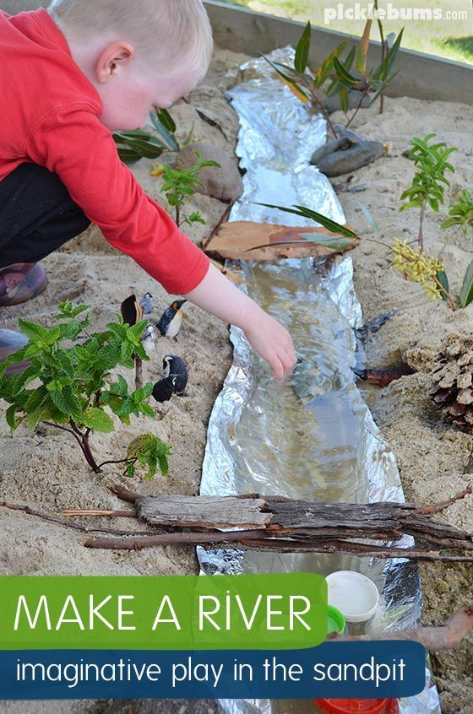

Example of Raft:
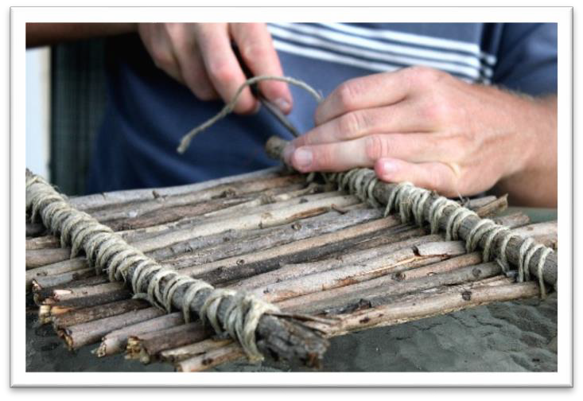

Children’s Activity (Holistic learning and development):  - Wellbeing  - Creativity and artistic skills  - Fine and gross motor skills  - Teamwork  - Problem solving |  | AFL:  - Children can generate ideas of the things their character might experience on their journey and recreate this physically on a small scale  - Children can use their scientific knowledge to create a raft that won't sink  - Children can assess their work and evaluate what is good and what they would change
Differentiation/Inclusion:

TA to work with SEN to help them access activities

Children’s Self-esteem/Independence skills:
I can:
- Generate ideas using inspiration from a book
- Work as a team to create a small-scale version of river journey
- Write a piece of text that accompanies my small structure

English in the Natural Curriculum Session Plan - Story Sack Year 6
Teacher: |  |  | Group/Class: |  | Number of pupils:
Title: George and The Dragon - George Wormell | Number of sessions: 1 |  | Duration: 1 hour and a half
Age Range of Children: Year 6
Aims:
- I can creatively make a small house for villagers that are shielding from the dragon
- I can use extended vocabulary to describe the house I have made and its features
Links to Natural Curriculum:
Key Stage 1 |  |  |  | Key Stage 2
 |  |  |  | - increasing their familiarity with a wide range of books, including myths, legends and traditional stories, modern fiction, fiction from our literary heritage, and books from other cultures and traditions
Prior Knowledge/Experience of group:
- Should have some knowledge of villages and the time period this is set through history work
- Behaviour and health and safety expectations known to children

Adult Role: (step by step instructions, including planned questions):

Story Sack contents:

George and The Dragon book
Dragon toy or picture
Village people (toys)
Pictures or models of little village houses

- Take children into forest school area and read the text to them
- Ask the children to describe what they think the villager’s houses would be like, would they have tv’s? central heating? What would their roofs and walls be made from?
- Explain to the children that the dragon that lives in the forest has destroyed their homes and whilst George is off to fight the dragon, we must re-build the villagers homes
- Children can use all-natural materials in their surroundings to build the miniature homes
- Demonstrate the safe use of small hand saws, twine etc
- Once children have finished creating their houses, arrange the structures into a village and get each pair to discuss their home, the choices they made and why.
- Self and peer assess

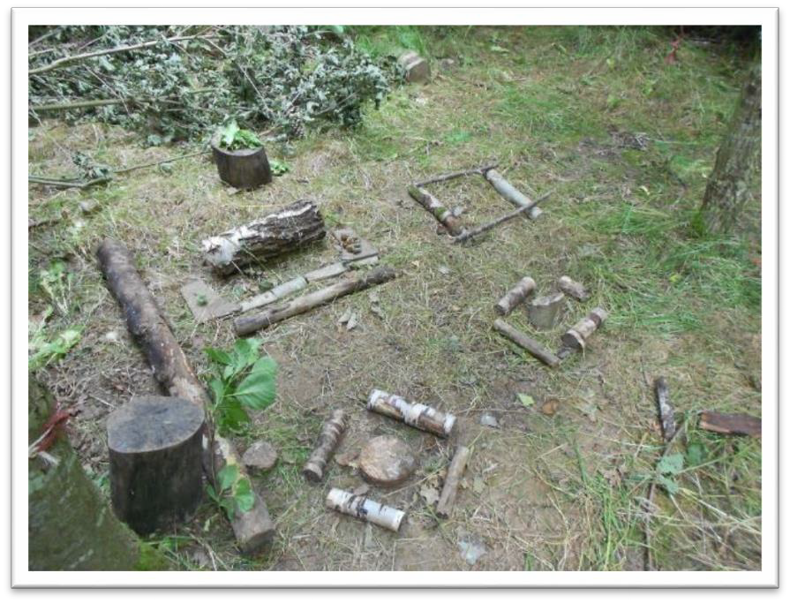

Children’s Activity (Holistic learning and development):  - Fine and gross motor skills  - Teamwork  - D&T  - Creativity |  | AFL:  - Children can use their prior existing knowledge to create sensible homes for the villagers  - Features are suitable for time period
Differentiation/Inclusion:

Ensure children are in mixed ability pairs to ensure LA are able to access the activity
Children’s Self-esteem/Independence skills:
I can:
- Create a small structure inspired by the text and my prior historical knowledge

