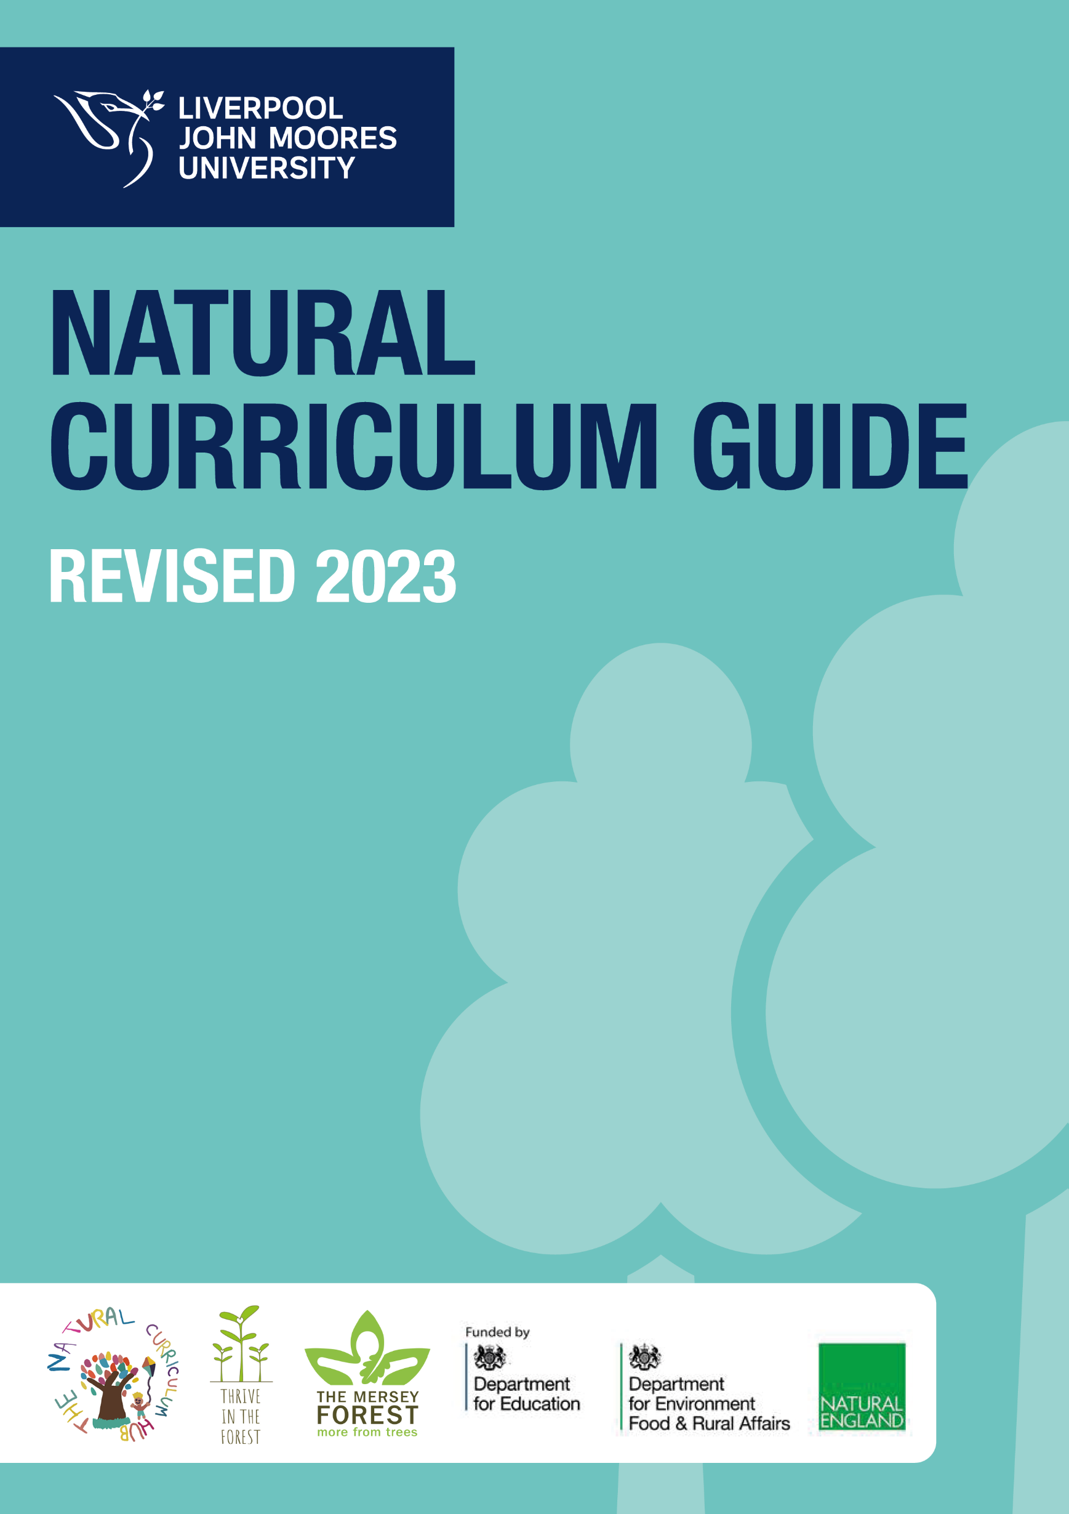
Revised 2025
MATHEMATICS
Mathematics in the Natural Curriculum
Number line activities
Learning Outcome:

To encourage number skills, counting sequences and place value (as appropriate for year group)

Year 1
Pupils should be taught to:
- compare, describe and solve practical problems for lengths and heights [for example, long/short, longer/shorter, tall/short, double/half]
- measure and begin to record lengths and heights
Year 2
- choose and use appropriate standard units to estimate and measure length/height in any direction (m/cm); mass (kg/g); temperature (°C); capacity (litres/ml) to the nearest appropriate unit, using rulers, scales, thermometers and measuring vessels
- compare and order lengths, mass, volume/capacity and record the results using >, < and =
Year 3
- measure, compare, add and subtract: lengths (m/cm/mm)

Resources:

Rope/string/stick
3 Whiteboards and pens

What to do:

- Lay out a rope or mark a line in the ground approximately 5 metres long.
- Write 0 on 1st whiteboard, 5 on 2nd whiteboard and 10 on 3rd whiteboard.
- Give these boards to 3 pupils and ask them to situate themselves along the line wherever they think that number should be. Hopefully they will have 0 and 10 at either end with 5 in the middle.
- Ask individual pupils to place themselves along the number line to show numbers between 1 and 10 and to explain to the rest of the group why they have placed themselves there. You can either choose the number for the pupils or ask them to choose for themselves and have the rest of the class guess the correct answer. E.g. I am number 2 which is near 0 but not quite halfway between 0 and 5.
- Peer assess each other’s placement along the line.
- Vary the number line for different year groups depending on focus in class:
  - Negative numbers
  - Decimal numbers
  - Fractions
  - Place value

Recording the height and circumference of the trees
Learning Outcome:

- To be able to solve a mathematical challenge.
- To be able to use and apply concepts and methods learnt previously.
- To be able to select the appropriate equipment to solve the challenge.

Pupils will need:

Found objects in the area (for graphs)
Trundle wheels
Whiteboards and pens
String
Sticks

What to do (height):

Estimating height

- Comparing the height of a tree by eye, to objects of a similar height provides a sense of scale. For example the height of the tree can be compared to a person or a nearby building. This can lead to discussions about closer objects looking bigger while those that are far away seem smaller. Think about what you need to do to make your estimate better.
- Working in pairs the children can estimate the height of a tree by measuring one child. This child then stands beside the tree. Their partner imagines how many times the measured child fits (head to foot) into the height of the tree (from the ground to the top of the tree). Multiply the number of times the child fits, say 4 times, by the height of the child, say 1 metre to get the height of the tree – in this example the tree is 4 metres tall.

More accurate measurements
- Pencil as a measuring tool:
  - Working in pairs, one child stays beside their tree while the other walks away from the tree but looks back at intervals.
  - When they look back the child holds a pencil at arms length vertically and lines it up with the tree.
  - Keep walking until the bottom of the tree is level with the bottom of the pencil, and the top of the tree is level with the top of the pencil.
  - Staying in the same spot, the child turns the pencil to a horizontal position, with the end of the pencil still at the base of the tree.
  - The child standing beside the tree now walks away from the tree, at a right angle until they reach the “point” of the pencil. The pencil holder will need to shout “stop” to their partner when they look like they are level with the point of their pencil. Then mark this spot.
  - The distance between this mark and the base of the tree is the height of the tree. The distance can be measured roughly by pacing out or exactly by using a measuring tape or trundle wheel.
- Looking through the legs: Show the children how to measure a tree height by viewing it through their legs.
  - Stand with legs apart and back to the tree.
  - Keeping legs straight, bend down and look at the tree between legs.
  - Move backwards or forwards so that they can just about see the top of the tree between their legs.
  - Measure the distance between their feet and the tree trunk roughly by pacing out or exactly by using a measuring tape or trundle wheel.
Teacher’s note: This works because maths says that if you view a tree’s top at a 45-degree angle then the height of the tree is equivalent to the distance that you are from that tree.
- 45° Triangle Method: This method requires a square piece of paper or card and a trundle wheel.
  - Fold the paper/card square in half to make a 45° right angle triangle.
  - Hold the triangle up to your eye and look along the longest side at the top of the tree.
  - Move backwards/forwards until your eye lines up with the top of the tree and the two shorter sides run parallel with the ground and tree trunk.
  - Measure the distance from where you stand in step 3 to the base of the tree. The distance is equal to the height of the tree from the height of your eye.
  - Add the measured distance/height to your eye height. Remember you calculated the tree height from your eye level and so you need to add your height for total tree height.
  - A limitation is when the tree has a spreading canopy, you might be unable to see the top with a 45-degree angle.
- Predict and then record the heights of a selection of trees in the outdoor learning area (use whiteboards to record the heights).
- Discuss how they would represent this information in a graph/chart form.
- Use string, found objects, sticks, to represent the information in the graph/chart. Work as a whole group and discuss as they go along whether it represents the data correctly.

What to do (circumference):
- Look at a variety of trees. Discuss which trees the children think are the oldest and why? (Older trees will tend to be taller, larger and with wider trunks.)
- If a log/cut stump of a tree trunk is available children can count the annual rings. Teacher’s note: It is, however, sometimes quite hard to see all the rings, particularly if they are very close together – so it may need to a rough estimate. The girth of a living tree can be used to estimate its age.
- The easiest way to get a measure of a tree’s girth is to use the outstretched arms of a number of children, touching one another’s fingertips, standing around the tree. Discuss how the girths of different trees vary. You can also experiment with different measures, like hand spans, around the tree. Discuss and decide how the children will get consistency in their measurements between different trees.
- Children can use a tape measure or piece of string, to measure around the trunk at approximately a child’s head height (about 1 metre from the ground) – measure to the nearest centimetre. This is the girth or circumference of the tree. Teacher’s note: Roughly, every 2.5cm of girth represents about one year’s growth. So to estimate the age of a living tree, divide the girth by 2.5. For example a tree with a girth of 40cm will be sixteen years old.
- Carry out a census of trees in the local area. Which are the oldest? Which are the youngest? (This information can be made into timelines or charts).
Teacher’s note: If you know the species of tree you are measuring, you can make this work more accurate, as different types of tree grow at different speeds.

Species of tree | Growth of girth per year (cm)
Average | 2.5
Oak and beech | 1.88
Pine and spruce | 3.13
Sycamore | 2.75

Look up the type of tree you have measured in the table and divide the girth by the number given. For example a sycamore with a girth of 110cm is about 40 years old (110 ÷ 2.75 = 40).

- Whether a tree is in woodland or in the open, also makes a difference to growth. Discuss why this is? Will woodland trees grow faster or slower than trees in the open? Teacher’s note: Trees in the open grow faster because there is less competition from other trees, for light, water and nutrients. You can build this into your calculations. For example, an average woodland tree increases in girth by approximately 1.25cm per year. Conifers (pines, spruces, larch, firs) usually grow a whorl of branches each year. If you count the number of whorls of branches up the trunk, you get an approximate age. This is easiest with young trees – up to about 20 years old!

Leaf Collection
Learning Outcome:

- To be able to solve a mathematical challenge.
- To be able to use and apply concepts and methods learnt previously.
- To be able to select the appropriate equipment to solve the challenge.

Pupils will need:

Found objects in the area (for graphs)
Buckets
Clipboards
Tally sheets
String
Sticks

What to do:

- Using the leaf identification swatches, collect a range of leaves from the area and identify the trees/shrubs from which they came.
- What shape are the leaves?
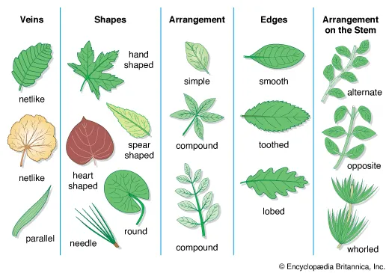
- Discuss what each leaf looks like and what regular shapes they think they look like e.g. oval, triangle, etc. What other mathematical language can they use to describe the leaves?
- Look around the area and do a tally of the number of trees/shrubs there are in the area that match each of the leaf types.
- Fill in the leaf tally sheets.
- Use the information from the tally sheets to construct a 3D graph on the ground using sticks and found objects.
- Peer assess the graphs and discuss the process together.

Patterns around us
Learning Outcome:
Pupils learn to identify patterns in the world around them and use mathematical language to describe them.

Pupils will need:

Patterns cards
Buckets

What to do:

- Using the cards and the buckets, pupils search the area for the patterns they can see.
- Where possible, collect objects that match the patterns on the cards.
- Discuss where they found the objects.
- Consider the main features of the patterns:
  - Are they repeating?
  - Are they symmetrical? How many lines of symmetry do they have?
  - Are they made up of straight lines or curved lines?
  - What are the colours they have found?
  - Are they a form of camouflage?
  - What shapes can they see in the patterns?
- Can they design their own leaf based on the features of those they have found and discuss the properties of this leaf. Be prepared to discuss this with the rest of the group/class.

Fabulous Fibonacci (3 lessons)
Learning Outcome:

- Explain Fibonacci numbers and their origin.
- Identify Fibonacci numbers in nature and art.
- Generate the next numbers in the Fibonacci sequence.
- Create an original number sequence.
- Create a Fibonacci rectangle and spiral.

Resources:

Pinecones
Flowers

What to do:

- Explain that Fibonacci was an Italian mathematician (real name Leonardo de Pisa). Fibonacci was an Italian mathematician from the Middle Ages who came up with a series of numbers called Fibonacci numbers. Each number added to the next makes the next number in the sequence and so on. E.g. 0, 1, 1, 2, 3, 5, 8, 13, 21, 34, 55 etc. This sequence of numbers then creates a physical pattern.
0, 1, 1, 2, 3, 5, (8, 13, 21, 34, 55, 89, 144 …)
- What is happening to these numbers? Can they guess which number comes next? Lay the first few numbers out on the ground in rows using sticks:

|
||
|||
|||||
||||||||
- Can they use sticks/leaves/found objects to continue the pattern of the numbers in the Fibonacci sequence?
- The sequence of numbers can make a physical pattern that appears in nature.

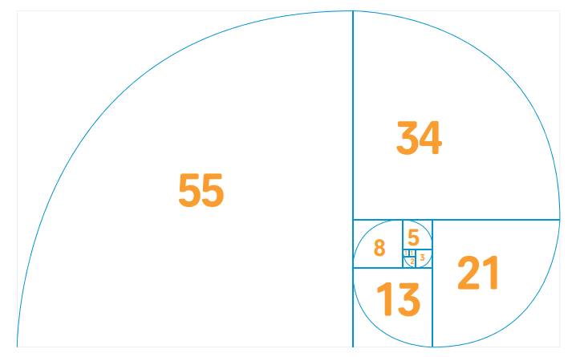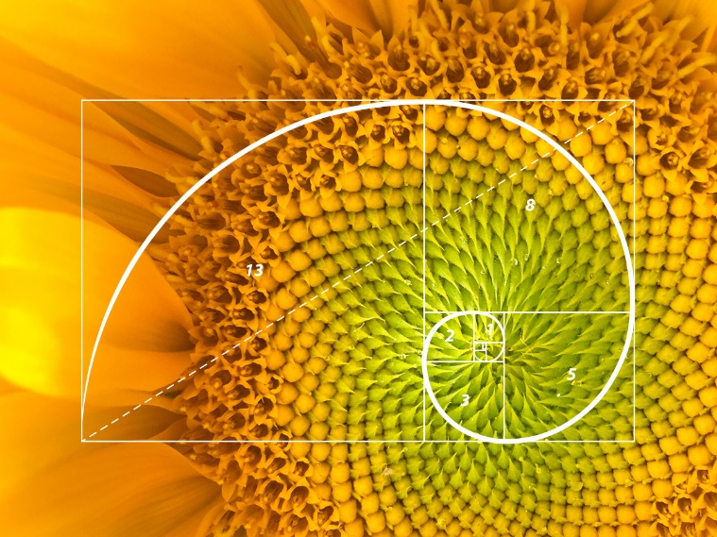

- Show the images of the pinecones from the pack:
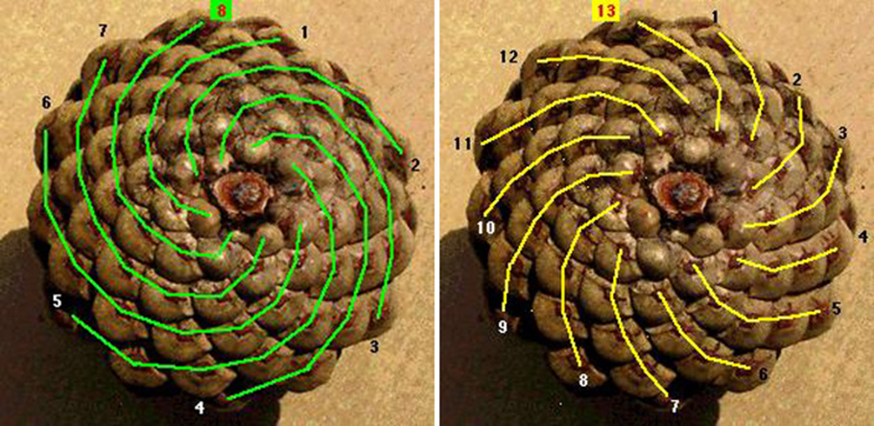

- What do they notice? (i.e. 13 and 8 are both Fibonacci numbers).
- Look at the lily on the card.
  - How many petals does it have?
  - Do they see six?
  - Is six a Fibonacci number?
  - Look more closely. Do they see that there are really two sets of three petals?
  - The outside petals with the straight edges are not really petals. They’re called sepals. So how many actual petals are there?

- Not all flowers have three petals. Some are hard to count because there are so many petals or they are in rows. And there are a few flowers that don’t have Fibonacci numbers for petals.
- See if they can find a daisy. Are the petals formed into a sequence using Fibonacci numbers?
- Search the area for objects that show the Fibonacci sequence in their formation.

Make a symmetrical insect from natural materials
Learning Outcome:
Pupils to make an insect out of natural materials which is symmetrical (older pupils can vary the number of lines of symmetry and types of symmetry on the insect).

Year 2
- identify and describe the properties of 2-D shapes, including the number of sides and line symmetry in a vertical line
Year 4
- identify lines of symmetry in 2-D shapes presented in different orientations
- complete a simple symmetric figure with respect to a specific line of symmetry

Pupils will need:

Air drying clay
Found objects from around the area
Whiteboards and pens

What to do:

- Find a range of natural materials and make a 2D insect (real or imaginary)
- Make the insect symmetrical
- How many lines of symmetry does it have?
- Peer assess each other’s insects and discuss what they have found.

Place Value
Learning Outcome:
Pupils to use the outdoor area to develop and consolidate understanding of place value of numbers (at relevant level for year group).

National Curriculum
Year 2
- recognise the place value of each digit in a two-digit number (tens, ones)
- read and write numbers to at least 100 in numerals and in words
- use place value and number facts to solve problems
- add and subtract numbers using concrete objects, pictorial representations, and mentally, including:
  - a two-digit number and ones
  - a two-digit number and tens
  - two two-digit numbers
  - adding three one-digit numbers
Year 3
- recognise the place value of each digit in a three-digit number (hundreds, tens, ones)
- compare and order numbers up to 1000
- read and write numbers up to 1000 in numerals and in words
- add and subtract numbers mentally, including:
  - a three-digit number and ones
  - a three-digit number and tens
  - a three-digit number and hundreds
Year 4
- recognise the place value of each digit in a four-digit number (thousands, hundreds, tens, and ones)
- order and compare numbers beyond 1000
Year 5
- read, write, order and compare numbers to at least 1 000 000 and determine the value of each digit
- count forwards or backwards in steps of powers of 10 for any given number up to 1 000 000
Year 6
- read, write, order and compare numbers up to 10 000 000 and determine the value of each digit

Pupils will need:

Sticks
Found objects from around the area
Whiteboards and pens

Number Run (Early Years, KS1, KS2)
You will need: Numbers distributed around the outside space. These could be on cards, written with a permanent marker on pebbles or plastic milk bottle lids, or the back of old CD’s, or chalked on the playground, etc.

- Ask the children to run around the space, then call out a number or a calculation. The children then run to the answer number.
- Call the children back to the centre and start again.

- Can be used for:

- Number recognition (including fractions, decimals and percentages and their equivalences)
- 1 more /1 less, 10 more/ 10 less etc
- Simple addition and subtraction
- Simple multiplication and division
- Doubles and halves etc

Treasure Hunt (Early Years / KS1):
You will need: a number of objects as ‘treasure’
(e.g. painted stones, pretend jewels, etc.)

- Hide your objects around the outdoor area and then ask the children then hunt for them.
- Then call them back together to talk about the ‘treasure’ they have found. e.g. How many jewels have you found? How might you count your jewels? How many jewels have you found? How can you be sure you have counted all of the jewels? Could you check in a different way? How could we sort the jewels? Who has collected the most / least? How do you know?

Hop, Skip, Jump (KS1, KS2)
You will need: Individual whiteboards and pens.

- Children hop, skip, jump etc around the space that they are working in.
- Call out a calculation.
- Children stop and write answer on the board.
- Children can either hold up their boards for the teacher to see or keep the answers as a list.

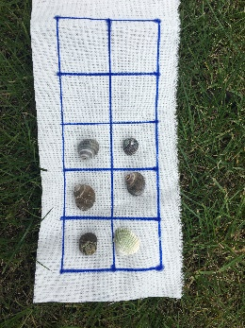
Outdoor Ten Frames (EYs, KS1, KS2)
- Ten-Frames are two-by-five rectangular frames into which counters / objects are placed to illustrate numbers less than or equal to ten, and are therefore very useful devices for developing number sense within the context of ten.
- Use egg boxes, bedding plant containers, old ice cube trays or recycled cotton material to make a 10-frame. alongside natural materials.

- See Julia Robertson’s blog with outdoor activities for using 10 frames.
https://creativestarlearning.co.uk/early-years-outdoors/the-joy-of-a-pocket-sized-cotton-ten-frame

- Use a ten-frame to also support understanding of decimals and fractions.

- Make a Number e.g. 4. There are so many different ways to make 4. Get, for example, four stones, and then experiment with a variety of formations. Children like comparing and copying their friends. This activity helps them visualise what a number actually looks like in its many manifestations. This is also excellent for one to one correspondence.

Ten-Frame Flash (5-7 years) Game for 4 players
You will need: blank ten-frame for each child, small stones, card to hide the ten-frame.

- One child puts some stones in their ten-frame and then shows it to their team mates for a count of three.
- They then hide it with a piece of card while the other children place stones in the same positions on their frames from memory.
- The 'flasher' shows their ten-frame again and helps each child check his/her display.
- The next child becomes the 'flasher' and so on, until everyone has had a turn.
- Points can be awarded for each correct response. The child with the most points wins.

Twenty (5-7 years) Game for 3-4 players
You will need: Blank ten-frames (2 per child), small stones, dice.

- Each child takes a turn to roll a die, and place that number of small stones onto his/her ten-frames and announce the total number of counters on their two frames. (Each player can also announce the number of counters needed to reach twenty).
- Repeat. The exact number must be rolled to win the game.
- The winner is the first player to fill all twenty spaces.

Guess What (6-8 years) Game for 2 players
You will need: Blank ten-frames, small stones, a large piece of cardboard to form a barrier between pairs of children.

- One player secretly arranges some small stones on a ten-frame.
- The other player asks closed questions that can be answered yes or no, trying to gain enough clues to work out the arrangement of counters on their ten frame. e.g. Is the top row full? Are there 8 counters? Is there an empty box in the bottom row?
- As players become more skilled, the number of questions can be counted. The player asking fewer questions wins.

Natural Numbers
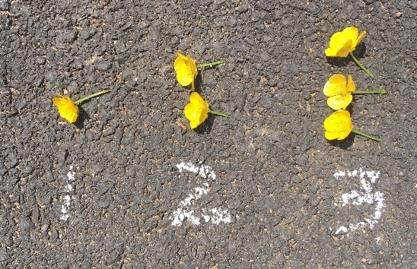
Use to practice one-to-one correspondence and number recognition or an understanding of place value.

You will need: Numbers written or digit cards placed on the playground; a number of natural materials e.g. a bucket of pine cones, flowers etc.

- Children place the number of pine cones to match the digit.

Variation:
- Children collect their own objects to represent numbers, link with place value milk tops.
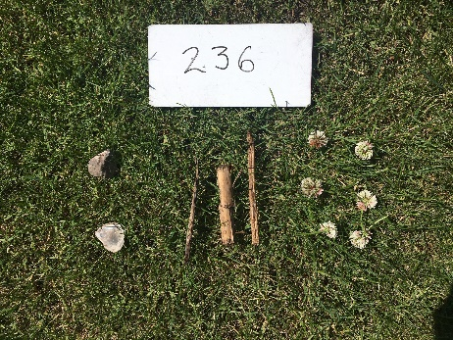
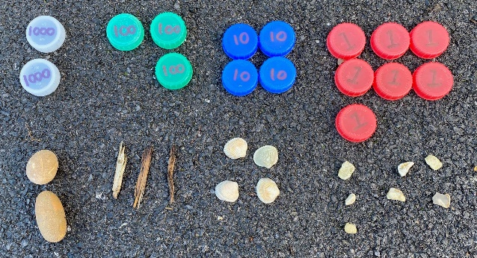

- Children can do some calculations.

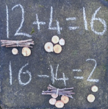
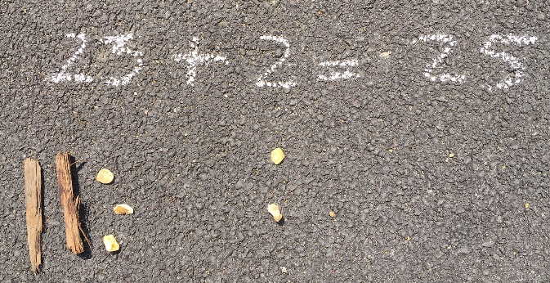

Comparing Numbers - Nature’s Way
A great activity for helping children to understand the concept of the 'greater than' and 'less than' symbols, as they can visually create them around the numbers.

You will need: A number of small objects (e.g. stones, acorns, flowers, etc), 4 thin sticks, chalk.

- Children collect a number of objects, e.g. seeds or pebbles etc, or you could use beads from the classroom.
- They then make number sentences using the ‘less than <’ and ‘more than signs >’.
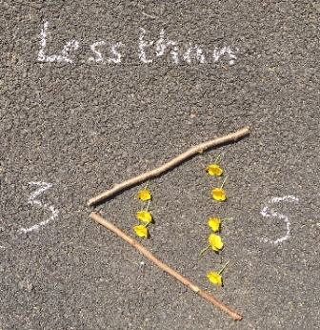
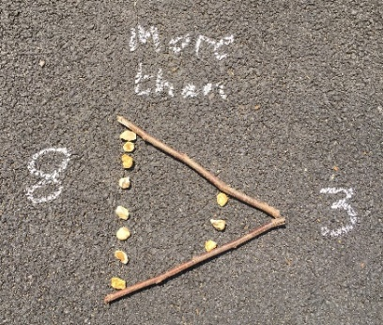

Playground Problem Questions
You will need: To write some word problems which require the children to explore the outdoors to find all the information they need to answer the question.

- e.g. Find a picnic table. How many legs has it got?
- How many legs would there be on 5 picnic tables?
- If there were 44 legs, how many picnic tables would there be?
- Or It costs 26p for every metre of painted lines on the school playground. How much would it cost to draw the line all the way round the netball court?
From Third Space Learning. https://thirdspacelearning.com

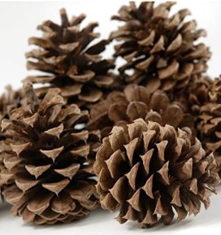
Natural Negative Numbers
You will need: sets of natural materials e.g. pebbles, shells. fir cones, twigs, etc, chalk.

- Give each child, pair or group, a set natural materials.
- Read out a number problem, and the children have to show their answer by creating it out of their natural resources as quickly as possible.
- You can differentiate through the questions:
e.g. which number is next in this sequence, -5, -4, -3?
Or, what is -7 plus -4? The children should show -11 on the ground.
Two Games for Reciting Numbers (EYs, KS1, KS1)
Can be played at any level.
e.g. Count:
- in 1’s, 10’s, 20’s, 25’s, 50’s, 100’s, 1000’s etc
- in odds and evens
- in multiples
- in fractions, decimals, percentages, powers of 10 etc.
- backwards through zero with negative numbers

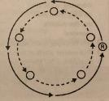
Beat the Ball
You will need: beanbags or balls.

- Divide the class into groups of about 6-8 of similar ability.
- Children make a circle and tell them which concept you are wanting them to practice. e.g. counting in 100’s, etc.
- The children pass the ball / beanbag around the circle with each child saying the correct number when they pass it.
- When they have said their number, that child runs round the circle and back to their place before the ball / beanbag gets to them again.
- If a child gets their answer wrong, then the rest of the team can help by shouting out the correct number and play continues.
- However that child still runs round the circle and back to their place before the ball / beanbag gets to them again.

Variation:
- Children change positions in the circle and change direction.

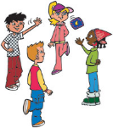
Pass the Bean Bag
You will need: Bean bag, ball or soft toy.

- Children stand in a circle.
- As they count, they have to pass the beanbag to the next person to answer.

Variation
- Instead of going sequentially round the circle, children can pass the beanbag across the circle.
- Or, with each successive incorrect answer the player loses an arm, leg or eye etc, but can gain it back with a correct answer.

You can also play this game having a large piece of rope / ribbon tied in a circle (or a raccoon circle). The knot gets passed round the circle as the children count.
Number Scavenger Hunts / Relay Race
Scavenger hunts or relay races where children have to find numbers and then order them, or then carry out calculations, can be a great active way to consolidate learning.

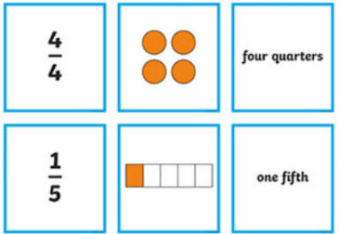
You will need: number cards of the concept you are focusing on (e.g. digit cards, numbers written as words, base 10 form, expanded form, giant coins, negative numbers, fractions, decimals, percentages, measurements written in different forms / units etc), pencil and paper, clipboards.

- Hide the cards around your outdoor space.
- In pairs, children hunt for all the number cards and write the numbers down on their clipboard.
- Once they have all the numbers, they can then carry out a number of different tasks
- e.g. order them from smallest to largest (or vice versa), or match number form to word form, match equivalent fractions or match decimal to fraction etc, carry out rounding etc.

Variations:
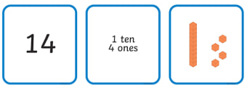
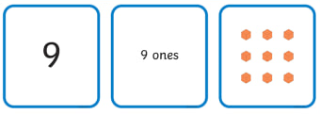
- Use different coloured cards to differentiate. Children are assigned a colour and find all the number on cards of that colour.
- If you have enough cards, the children could collect the cards and use for ordering / matching / rounding etc.

- You can also run this activity as a relay race. In teams, children have to collect the cards from a central place.
- Once children have the cards they can then sort them or carry out the tasks you require.
- e.g. sort the cards using Venn diagrams or Carroll diagrams, either with criteria you set them or children could devise their own.
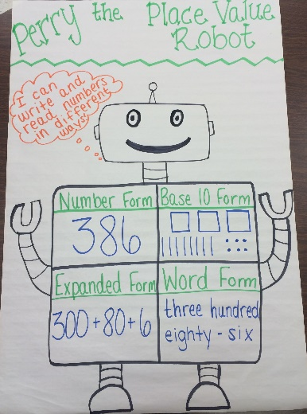
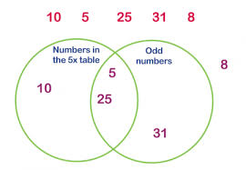

- The cards could be a single type or a mixture of: Number Form, Base 10 Form, Expanded Form, Word Form. For each card that they have collected, children could complete all the squares in The Place Value Robot.

Missing Number (EYs, KS1, KS2)
You will need: chalk, natural materials, e.g. sticks, pebbles, fir cones etc.
- Draw an empty number line e.g. 0-100 on the playground.
- Depending on the ability of the children, you may want to put other marker numbers on it.
- Indicate a missing number on the line. Children need to use natural materials to represent that number e.g. stick =10, pebble = 1. Are they correct?
- Can they set a challenge for another pair to solve?

Variation
- You can also do this activity with a long stick and use cubes or small twigs etc to mark out multiples of 10 to help find the missing numbers.
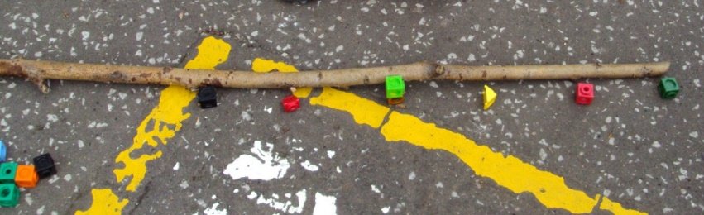
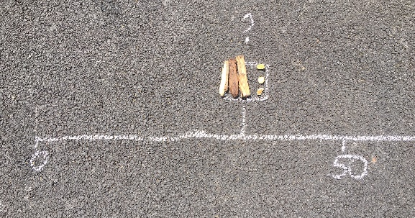

Place Value in the Playground (EYs, KS1, KS2)
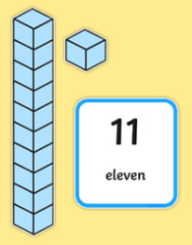
You will need: cards with tens or ones on them (or could use Dienes or place value milk bottle lids).

- Give each child a card with either a ten or a one on it.
- Call out a two-digit number.
- The children have to get into groups with the correct number of tens and ones. Some unfortunately will be left over.

Variation:
- You can also draw tens and ones columns on the playground in chalk /mark out with masking tape. Each child has to stand in the correct column to make their group number.
- You can also do this activity with hundreds, thousands as well as decimals.

Ordering HTO (KS1, KS2)
You will need: 0-9 digit cards (or 0-9 labelled plastic milk bottle lids), so each child has a digit card. Whiteboard and pens can be useful for recording.

- Each pupil is given a digit card (0-9).
- They run around the playground.
- When you shout ‘Group’ the children have to get into a group of three.
- Then in their threes, the children make numbers from your instructions:
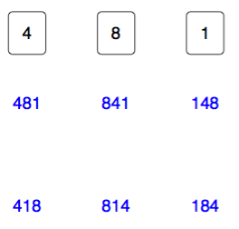
  - e.g. Make the largest number you can.
  - Make the smallest number you can.
  - Make all the numbers you can and record on your whiteboard.
- Discuss some of the solutions. Why did you put the 2 there? Is it always possible to make an even number? etc. Can the children explain how they decided where to put each digit?
- When each group has made their three digit number, can the class put all the 3 digit numbers in order from smallest to largest?

Variations
- Use for Th, H, T, O, decimals etc, as appropriate.

Multiplying and Dividing By 10, 100, 1000. (KS2)
This kinaesthetic approach helps children cement the concept.
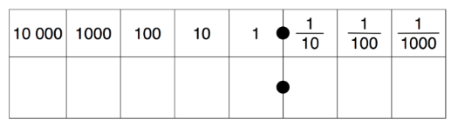
You will need: large 0-9 digit cards.
On the playground, using chalk or masking tape, draw a place value grid, for the size of numbers you are focussing on.

- e.g. HTO: Give out 3 digit cards and ask children to stand in the correct columns to create a 3 digit number.
- When you ask them to multiply their number by ten, they physically have to move themselves to the left into the next place value column. They will also see the need for the place holder zero.
- Repeat with other numbers multiplying and dividing accordingly.

HTO Coded Relay (KS2)
A great game to play to help secure place value and partitioning.

You will need: a list of numbers of the size you are focusing on.
- Group children into even teams (ideally a maximum 6).
- The first person from each team runs up to the teacher who gives them a number.
- They then run to the back of their line. The aim is to pass the number to the front person without speaking, but using a code.
- They tap the person in front of them:
    - Left shoulder for 100’s
    - Head for 10’s
    - Right shoulder for ones.
- e.g. 645 would be six taps on the left shoulder, four on the head and five on the right.
- Each person waits for the coded number to reach them, then passes it forward until it reaches the front.
- They then put their hand up to show when the person in the front of the team has received the number.
- Check the answer from the teams.
Variations:
- You can play this with different size numbers (and decimals), just add in more code actions.
- Children could develop their own codes to represent the different place value columns.
Websites:
- Maths Outdoors – plenty of ideas for number activities outdoors.
https://creativestarlearning.co.uk/c/maths-outdoors

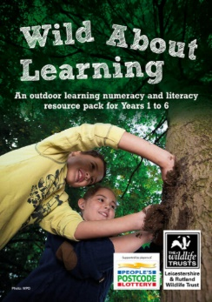
- Wild About Learning. An outdoor learning numeracy and literacy resource pack for Years 1 to 6, produced by Leicestershire and Rutland Wildlife Trust.
http://www.wildforestschool.org.uk/wild-about-learning

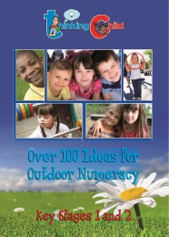

- Over 100 Ideas for Outdoor Numeracy for KS1 and KS2 by Sue Dixon founder of The Thinking Child. Includes number activities.
https://creativestarlearning.co.uk/wp-content/uploads/2020/05/Outdoor-Numeracy-Pack-LowRes.pdf

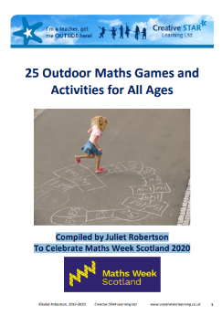
- 25 Outdoor Maths Games and Activities for All Ages
Compiled by Juliet Robertson, to Celebrate Maths Week Scotland 2020.
https://www.mathsweek.scot/assets/images/25-Outdoor-maths-games-for-Everyone_2020-09-21-130731.pdf

- Learning Through Landscapes Free maths resources for outdoor learning. https://www.ltl.org.uk/free-resources

Leaf Study
Shape |  | Tally |  |  | Number
 | Tree Study
 | Tree Species
 |  |  | cm | m
 | Height
 | Circumference
 | Leaf shape |  | Draw a picture of the leaf shape.
 | Tree shape |  | Draw a picture of the tree shape.

