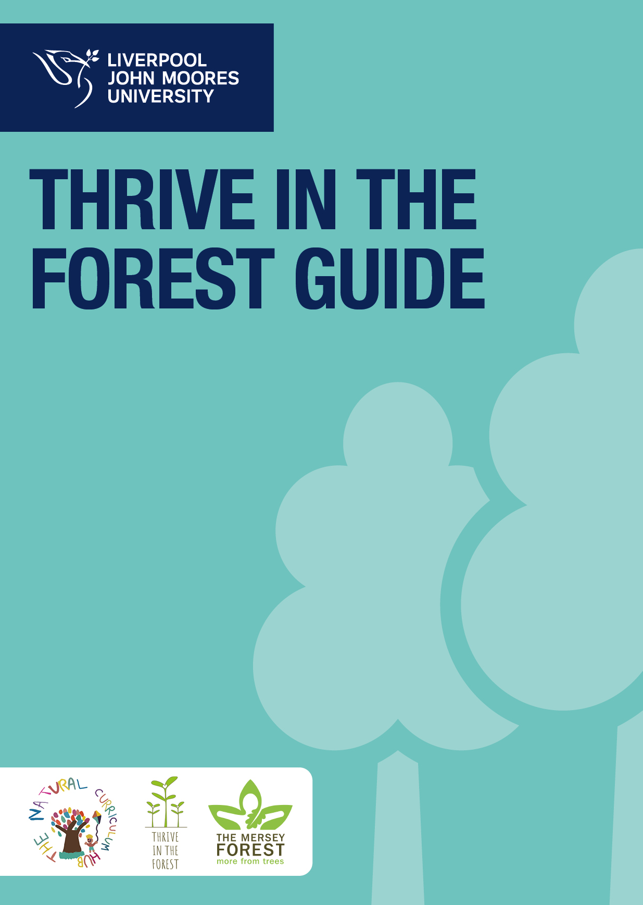

Thrive in the Forest Session Plan

Teacher: |  |  | Group/Class: |  | Number of pupils:
Title: Introduction to Thrive in the Forest | Number of sessions: 6 |  | Duration: 6 sessions @ 1.5 hours
Age Range of Children: 5-11
Aims:
- To develop an understanding of the ethos of Thrive in the Forest pedagogies.
- Introducing Thrive in the Forest and fire safety (for toasting marshmallows and boiling water for hot chocolate).
- To introduce a range of simple Thrive in the Forest activities including:
  - Scavenger Hunt (Colour Swatches)
  - Building a shelter
  - Hug a tree
  - Art activities
  - Collaborative activities
  - Teamwork
- Reflect on own learning in the Thrive in the Forest Setting (language development)
Links to PSHE:
Key Stage 1 |  |  |  | Key Stage 2
H1. about what keeping healthy means; different ways to keep healthy  H2. about foods that support good health and the risks of eating too much sugar  H8. how to keep safe in the sun and protect skin from sun damage  H9. about different ways to learn and play; recognising the importance of knowing when to take a break from time online or TV  H11. about different feelings that humans can experience  H12. how to recognise and name different feelings  H17. about things that help people feel good (e.g. playing outside, doing things they enjoy, spending time with family, getting enough sleep)  H18. different things they can do to manage big feelings, to help calm themselves down and/or change their mood when they don’t feel good  H23. to identify what they are good at, what they like and dislike  H24. how to manage when finding things difficult  H28. about rules and age restrictions that keep us safe  H29. to recognise risk in simple everyday situations and what action to take to minimise harm  H32. ways to keep safe in familiar and unfamiliar environments (e.g. beach, shopping centre, park, swimming pool, on the street) and how to cross the road safely  R6. about how people make friends and what makes a good friendship  R8. simple strategies to resolve arguments between friends positively  R24. how to listen to other people and play and work cooperatively  L1. about what rules are, why they are needed, and why different rules are needed for different situations  L2. how people and other living things have different needs; about the responsibilities of caring for them  L3. about things they can do to help look after their environment |  |  |  | H2. about the elements of a balanced, healthy lifestyle  H3. about choices that support a healthy lifestyle, and recognise what might influence these  H7. how regular (daily/weekly) exercise benefits mental and physical health (e.g. walking or cycling to school, daily active mile); recognise opportunities to be physically active and some of the risks associated with an inactive lifestyle  H12. about the benefits of sun exposure and risks of overexposure; how to keep safe from sun damage and sun/heat stroke and reduce the risk of skin cancer  H16. about strategies and behaviours that support mental health — including how good quality sleep, physical exercise/time outdoors, being involved in community groups, doing things for others, clubs, and activities, hobbies and spending time with family and friends can support mental health and wellbeing  H20. strategies to respond to feelings, including intense or conflicting feelings; how to manage and respond to feelings appropriately and proportionately in different situations  H27. to recognise their individuality and personal qualities  H28. to identify personal strengths, skills, achievements and interests and how these contribute to a sense of self-worth  H29. about how to manage setbacks/perceived failures, including how to re-frame unhelpful thinking  H37. reasons for following and complying with regulations and restrictions (including age restrictions); how they promote personal safety and wellbeing with reference to social media, television programmes, films, games and online gaming  H38. how to predict, assess and manage risk in different situations  R14. that healthy friendships make people feel included; recognise when others may feel lonely or excluded; strategies for how to include them  R31. to recognise the importance of self-respect and how this can affect their thoughts and feelings about themselves; that everyone, including them, should expect to be treated politely and with respect by others (including when online and/or anonymous) in school and in wider society; strategies to improve or support courteous, respectful relationships  L1. to recognise reasons for rules and laws; consequences of not adhering to rules and laws  L3. about the relationship between rights and responsibilities  L5. ways of carrying out shared responsibilities for protecting the environment in school and at home; how everyday choices can affect the environment (e.g. reducing, reusing, recycling; food choices)
Prior Knowledge/Experience of group:
This is the group’s first session in Thrive in the Forest.
Resources:  - Kelly Kettle  - Fire lighters  - Cotton wool  - Kindling and firewood  - Vaseline  - Blindfolds  - Ribbons  - Colour Swatches  - Fabric, pegs, string, canes, groundsheets  - Olly Owl (KS1 groups) |  | Health and Safety:  - Slip, trip, fall, fracture.  - Collision.  - Muscle strain, Ligament sprain.  - Misuse of equipment.  - Trigger of medical condition e.g. Asthma attacks, diabetes, epilepsy, etc.  - Tripping over the obstacles / fall from height/ stacked timber/wood.  - Hypothermia, cold.  - Fighting.  - Blind fold games.  - Falling branches – head or other injury.  - Dirty hands – infections.  - Insects, wasps, plants, fungi – possible allergic reaction, poisoning, choking.  - Lost children (while visiting toilets), potential abduction.  - Fire hazard – scalds, forest fire.
Adult Role: (step by step instructions, including planned questions):

Activity 1: Thrive in the Forest Song

To the tune of ‘Here we go round the mulberry bush’, sing the chorus ‘Here we go round the fire pit, the fire pit, the fire pit, Here we go round the fire pit on a bright and sunny/dull and cloudy/wet and rainy day’.

Aim: To reinforce safe entry into the Thrive in the Forest area and expectations for conduct while carrying out activities during the session and when the fire is lit.

Demonstrate safe entry into the fire circle area and explain expectations for conduct while carrying out activities.
SALLEY SQUIRREL CIRCLE
Activity 2: Invisible Ball

This game is essentially playing catch with one or several invisible balls.
- The children all stand in a circle.
- Explain that you are holding an invisible ball.
- Call a child’s name and throw them the ball.
- They have to mime catching the ball. They then call someone else’s name and throw the ball to them.
- Once everyone feels confident with the game, you can introduce a second and possibly third ball.
- Vary the number of balls thrown around the circle at a time.

Activity 3: Colour Swatch Hunt

Pairs (with an adult where appropriate)
- Find specific objects that match the colours on their chosen swatch.
- Collect objects into buckets
- Return to the Circle for discussion and comparison.
Resources: Colour swatches, buckets.

Activity 4: Shelter building

In groups (with adult to guide where appropriate).

- Use string, pegs, fabric or found objects from around the woodland space to make a shelter in which all children can stand upright.
- Ask the children to lie down on their backs and raise their fists
- Every time they hear a new bird song they should put up a finger
- See if you can count to ten without hearing a bird song.
- Different versions of this game can be played by concentrating on other sounds.
- Peer assessment of dens – which is the best one for all weathers? Can the whole group stand upright under the canopy?

Resources: Fabric, pegs, string, canes, groundsheets, found objects in the space.

Activity 5: Hug a Tree

In groups with an adult to guide:
- Prepare for the activity by marking double the number of trees to children in your group using the ribbons
- Pair up the children and instruct them how to lead each other safely if one of them is blindfolded. Tell them that they are going to get to know their own special tree in the wood – they should feel its bark, the shape of its leaves, anything growing at the bottom, where the branches start and how many there are, what it smells like, how wide its trunk is etc.
- One child in the pair then leads the other blindfolded to a marked tree of their choice and they have a few minutes to get to know this tree.
- On a given signal the children return to the starting point STILL WEARING THEIR BLINDFOLDS.
- Only then can they remove the blindfolds – they then have three guesses to identify their tree. Encourage them to feel, look carefully and remember.
- The pair can then swap roles and repeat the activity.

Resources: Blindfolds, ribbons

Activity 6 – Word up!

Aim: Students are to summarise the session in one word. They will justify their reasoning with the group.

Students are to find an individual spot within the Thrive in the Forest area.
The teacher/leader will explain that the aim of this task is for the students to carefully consider one key word they could use to summarise the session.
Once students have had an opportunity to think internally, split the group into smaller groups (depending on class numbers, this will vary) where they will take turns sharing their key words. To build upon this, ask students to explain why they selected that word to their small group, making sure they refer to the session in some way. This will allow all children to have the opportunity to rehearse verbalising their opinion before sharing with the teacher/leader and the whole group.
After this, gather group into a larger circle.
Ask students to share their key word and justification for their word to celebrate today’s session.

Ongoing with staff – making hot chocolate and toasted marshmallows.

Children need to demonstrate an awareness of fire safety at all times by following the demonstrated procedures and moving in a safe manner around the fire. Do not cross the fire circle – always walk around the fire pit with care. Marshmallows need to be toasted by holding the stick at the far end; avoid letting fingers touch the hot part of the stick; wait for the marshmallow to cool slightly before touching. Children to kneel with one leg up to support them when toasting marshmallows. All children will be closely monitored by adults when they are around the fire pit.

Resources: Kelly Kettles, cotton wool, fire steels, kindling, wood, fire pit, marshmallows, chocolate digestives, plastic cups, water (for hot chocolate and enough to put out fire in an emergency and at the end of the session). Emergency Fire Safety Kit will be situated near the fire pit in case of emergency.

Children’s Activity (Holistic learning and development):  - Development of gross and fine motor skills  - Language development  - Confidence skills  - Wellbeing  - Behaviour  - Social interaction/group work. |  | AFL:  - Teacher assessment of activities (ongoing).  - Den making – did the den meet the success criteria? Self and peer assessment.
Differentiation/Inclusion:
Children will work in groups and pairs and will be guided by an adult to ensure that they are scaffolded throughout all their activities to aid with cooperative activities and language skills.
Children’s Self-esteem/Independence skills:
I can:
- Build a den
- Work with others
- Find objects in the Thrive in the Forest area
- Identify a range of trees using descriptive language
Links to theories (tick as appropriate):
- Groupwork - Social constructivism (Vygotsky)
- Contextual Learning - Concrete Operational Stage (Piaget)
- Schema (Piaget) including:
  - Transporting – carrying containers/bags/tarps/
  - Enveloping – cover/hide selves, hunt for treasures, hide in dens
  - Enclosure – building small structures
  - Filling – buckets with treasure
  - Boundary – crossing either physically or with objects, building dens
- Finding objects in the space to put together to complete a product/outcome – Loose Parts (Simon Nicholson)
- Problem solving – Possibility Thinking (Anna Craft)

Thrive in the Forest Session Plan

Teacher: |  |  | Group/Class: |  | Number of pupils:
Title: Introduction to Thrive in the Forest | Number of sessions: 6 |  | Duration: 6 sessions @ 1.5 hours
Age Range of Children: 5-11
Aims:
- To continue to develop an understanding of the ethos of Thrive in the Forest pedagogies.
- To reinforce Thrive in the Forest and fire safety (for toasting marshmallows and boiling water for hot chocolate).
- To introduce a range of simple ‘Thrive in the Forest’ activities including:
  - Signs of Spring
  - Hug a tree
  - Make a bird feeder
  - Marshmallows around the fire
- Reflect on own learning in the Thrive in the Forest Setting (language development)

Links to PSHE:
Key Stage 1 |  |  |  | Key Stage 2
- H1. about what keeping healthy means; different ways to keep healthy.  - H2. about foods that support good health and the risks of eating too much sugar.  - H8. how to keep safe in the sun and protect skin from sun damage.  - H9. about different ways to learn and play; recognising the importance of knowing when to take a break from time online or TV.  - H11. about different feelings that humans can experience.  - H15. to recognise that not everyone feels the same at the same time or feels the same about the same things.  - H16. about ways of sharing feelings; a range of words to describe feelings.  - H17. about things that help people feel good (e.g., playing outside, doing things they enjoy, spending time with family, getting enough sleep).  - H23. to identify what they are good at, what they like and dislike.  - H24. how to manage when finding things difficult.  - H28. about rules and age restrictions that keep us safe.  - H29. to recognise risk in simple everyday situations and what action to take to minimise harm.  - H32. ways to keep safe in familiar and unfamiliar environments (e.g., beach, shopping centre, park, swimming pool, on the street) and how to cross the road safely.  - R6. about how people make friends and what makes a good friendship.  - R7. about how to recognise when they or someone else feels lonely and what to do.  - R8. simple strategies to resolve arguments between friends positively.  - R24. how to listen to other people and play and work cooperatively.  - L1. about what rules are, why they are needed, and why different rules are needed for different situations.  - L2. how people and other living things have different needs; about the responsibilities of caring for them.  - L3. about things they can do to help look after their environment. |  |  |  | - H2. about the elements of a balanced, healthy lifestyle.  - H3. about choices that support a healthy lifestyle and recognise what might influence these.  - H7. how regular (daily/weekly) exercise benefits mental and physical health (e.g., walking or cycling to school, daily active mile); recognise opportunities to be physically active and some of the risks associated with an inactive lifestyle.  - H12. about the benefits of sun exposure and risks of overexposure; how to keep safe from sun damage and sun/heat stroke and reduce the risk of skin cancer.  - H20. strategies to respond to feelings, including intense or conflicting feelings; how to manage and respond to feelings appropriately and proportionately in different situations.  - H24. problem-solving strategies for dealing with emotions, challenges and change, including the transition to new schools.  - H27. to recognise their individuality and personal qualities.  - H28. to identify personal strengths, skills, achievements and interests and how these contribute to a sense of self-worth.  - H29. about how to manage setbacks/perceived failures, including how to re-frame unhelpful thinking.  - H37. reasons for following and complying with regulations and restrictions (including age restrictions); how they promote personal safety and wellbeing with reference to social media, television programmes, films, games and online gaming.  - H38. how to predict, assess and manage risk in different situations.  - H39. about hazards (including fire risks) that may cause harm, injury or risk in the home and what they can do reduce risks and keep safe.  - H41. strategies for keeping safe in the local environment or unfamiliar places (rail, water, road) and firework safety; safe use of digital devices when out and about.  - R10. about the importance of friendships; strategies for building positive friendships; how positive friendships support wellbeing.  - R14. that healthy friendships make people feel included; recognise when others may feel lonely or excluded; strategies for how to include them.  - R30. that personal behaviour can affect other people; to recognise and model respectful behaviour online.  - R31. to recognise the importance of self-respect and how this can affect their thoughts and feelings about themselves; that everyone, including them, should expect to be treated politely and with respect by others (including when online and/or anonymous) in school and in wider society; strategies to improve or support courteous, respectful relationships.  - L1. to recognise reasons for rules and laws; consequences of not adhering to rules and laws.  - L4. the importance of having compassion towards others; shared responsibilities we all have for caring for other people and living things; how to show care and concern for others.  - L5. ways of carrying out shared responsibilities for protecting the environment in school and at home; how everyday choices can affect the environment (e.g., reducing, reusing, recycling; food choices).
Prior Knowledge/Experience of group:
This is the group’s 2nd session in Thrive in the Forest and, after evaluation of last week, we have decided to focus on trust activities and paired work to engage the children in the environment around them.

Resources:  - Fire lighters  - Cotton wool  - Kindling and firewood  - Vaseline  - Blindfolds  - Ribbons  - Peanut Butter  - Craft Sticks  - Bird seed  - Toilet paper rolls  - Twine  - Olly Owl |  | Health and Safety:  - Slip, trip, fall, fracture.  - Collision.  - Muscle strain, Ligament sprain.  - Misuse of equipment.  - Trigger of medical condition e.g., Asthma attacks, diabetes, epilepsy, etc.  - Tripping over the obstacles / fall from height/ stacked timber/wood.  - Hypothermia, cold.  - Fighting.  - Blind fold games.  - Falling branches – head or other injury.  - Dirty hands – infections.  - Insects, wasps, plants, fungi – possible allergic reaction, poisoning, choking.  - Lost children (while visiting toilets), potential abduction.  - Fire hazard – scalds, forest fire
Adult Role: (step by step instructions, including planned questions):

Activity 1: Thrive in the Forest Song

To the tune of ‘Here we go round the mulberry bush’, sing the chorus ‘Here we go round the fire pit, the fire pit, the fire pit, Here we go round the fire pit on a bright and sunny/dull and cloudy/wet and rainy day’.

Aim: To reinforce safe entry into the Thrive in the Forest area and expectations for conduct while carrying out activities during the session and when the fire is lit.
SALLEY SQUIRREL CIRCLE
Activity 2: Signs of Spring (activity can be adapted to each season)

Pairs with an adult to find signs of spring in the FS area, such as:
- Buds
- Minibeasts
- Spring flowers
- Leaves
Resources: none required.

Activity 3: Creeping Comanche

- The children all choose an item located within the woodland (e.g., a coat, notebook, pen, large stick etc).
- The children stand in a circle with one person stood in the centre.
- The person in the centre is blindfolded.
- The children in the circle must try and creep towards the person in the centre and place their item at their feet without being heard.
- If the person in the centre hears them and points to them, they must return to the edge of the circle and start again.

To differentiate (if necessary):
- Playing the game on different ground surfaces can make it easier or harder.
- The size of the circle can be adjusted to make the game easier or harder.

Resources: a blindfold, items for children to place during game.

Activity 4: Make a bird feeder

Discuss the needs of birds over winter and in early spring. How can we help birds to survive in the cold weather when there is no food for them?

- Using a craft stick, cover outside of toilet paper roll with peanut butter.
- Roll the peanut butter covered toilet paper roll in the birdseed until covered.
- Thread a piece of twine through the toilet paper roll and knot (adult help).
- Spend time finding a place in the Thrive in the Forest to locate the feeder to get maximum benefit for the birds. Will they be safe from predators, such as cats, while they are feeding?

Resources: Peanut Butter, Craft Sticks, Bird seed, Toilet paper rolls, Twine

Activity 5: Olly Owl

Whole group led by teacher.
Olly Owl asks the children in turn about their experiences using such questions as:
- Did anything make you laugh today?
- Did you feel proud of anything you did today?
- Did anybody help you to do something today?
- Did you feel unhappy about doing anything today?
- Did you try something new today?
- Have you learned anything new about someone else?

Resources: Olly Owl cuddly toy, story sack containing visual aids.

Ongoing with LJMU Staff – making hot chocolate and toasted marshmallows.

Children need to demonstrate an awareness of fire safety at all times by following the demonstrated procedures and moving in a safe manner around the fire. Do not cross the fire circle – always walk around the fire pit with care. Marshmallows need to be toasted by holding the stick at the far end; avoid letting fingers touch the hot part of the stick; wait for the marshmallow to cool slightly before touching. Children to kneel with one leg up to support them when toasting marshmallows. All children will be closely monitored by adults when they are around the fire pit.

Resources: cotton wool, fire steels, kindling, wood, fire pit, marshmallows, chocolate digestives, plastic cups, water (for hot chocolate and enough to put out fire in an emergency and at the end of the session). Emergency Fire Safety Kit will be situated near the fire pit in case of emergency.

Children’s Activity (Holistic learning and development):  - Development of gross and fine motor skills  - Language development  - Confidence skills  - Wellbeing  - Behaviour  - Social interaction/group work |  | AFL:  - Teacher assessment of activities (ongoing).  - Hug a tree – what senses did we use to find our tree? Self and peer assessment.  - Bird feeder – where did we put our feeder? Was it a good place for the birds to find the food and eat it safely?
Differentiation/Inclusion:
Children will work in groups and pairs and will be guided by an adult (either instructors or LJMU trainees) to ensure that they are scaffolded throughout all their activities to aid with reading and language skills.

Children’s Self-esteem/Independence skills:
I can:
- Work with others
- Learn new songs
- Find signs of spring in the Thrive in the Forest
- Identify a range of trees, spring flowers
- Make own birdfeeder and understand the significance of supporting animals throughout the year.

Links to theories:
- Social constructivism (Vygotsky)
- Concrete Operational Stage (Piaget)
- Schema (Piaget) including:
  - Transporting – carrying containers/bags/tarps/
  - Enveloping – cover/hide selves, hunt for treasures, hide in dens
  - Boundary – crossing either physically or with objects, building dens

Thrive in the Forest Session Plan

Teacher: |  |  | Group/Class: |  | Number of pupils:
Title: Introduction to Thrive in the Forest | Number of sessions: 6 |  | Duration: 6 sessions @ 1.5 hours
Age Range of Children: 5-11
Aims:
- To continue to develop an understanding of the ethos of Thrive in the Forest pedagogies.
- To reinforce Thrive in the Forest and fire safety (for toasting marshmallows and boiling water for hot chocolate).
- To introduce a range of simple ‘Thrive in the Forest’ activities including:
  - Find an animal habitat
  - Make a nest
  - Marshmallows around the fire
- Reflect on own learning in the Thrive in the Forest Setting (language development).

Links to PSHE:
Key Stage 1 |  |  |  | Key Stage 2
- H1. about what keeping healthy means; different ways to keep healthy.  - H2. about foods that support good health and the risks of eating too much sugar.  - H3. about how physical activity helps us to stay healthy; and ways to be physically active every day.  - H8. how to keep safe in the sun and protect skin from sun damage.  - H9. about different ways to learn and play; recognising the importance of knowing when to take a break from time online or TV.  - H14. how to recognise what others might be feeling.  - H15. to recognise that not everyone feels the same at the same time, or feels the same about the same things.  - H17. about things that help people feel good (e.g., playing outside, doing things they enjoy, spending time with family, getting enough sleep).  - H18. different things they can do to manage big feelings, to help calm themselves down and/or change their mood when they don’t feel good.  - H23. to identify what they are good at, what they like and dislike.  - H24. how to manage when finding things difficult.  - H28. about rules and age restrictions that keep us safe.  - H29. to recognise risk in simple everyday situations and what action to take to minimise harm.  - H32. ways to keep safe in familiar and unfamiliar environments (e.g., beach, shopping centre, park, swimming pool, on the street) and how to cross the road safely.  - H35. about what to do if there is an accident and someone is hurt.  - R7. about how to recognise when they or someone else feels lonely and what to do.  - R8. simple strategies to resolve arguments between friends positively.  - R22. about how to treat themselves and others with respect; how to be polite and courteous.  - R24. how to listen to other people and play and work cooperatively.  - L1. about what rules are, why they are needed, and why different rules are needed for different situations.  - L2. how people and other living things have different needs; about the responsibilities of caring for them.  - L3. about things they can do to help look after their environment. |  |  |  | - H2. about the elements of a balanced, healthy lifestyle.  - H3. about choices that support a healthy lifestyle, and recognise what might influence these.  - H7. how regular (daily/weekly) exercise benefits mental and physical health (e.g., walking or cycling to school, daily active mile); recognise opportunities to be physically active and some of the risks associated with an inactive lifestyle.  - H12. about the benefits of sun exposure and risks of overexposure; how to keep safe from sun damage and sun/heat stroke and reduce the risk of skin cancer.  - H16. about strategies and behaviours that support mental health — including how good quality sleep, physical exercise/time outdoors, being involved in community groups, doing things for others, clubs, and activities, hobbies and spending time with family and friends can support mental health and wellbeing.  - H20. strategies to respond to feelings, including intense or conflicting feelings; how to manage and respond to feelings appropriately and proportionately in different situations.  - H24. problem-solving strategies for dealing with emotions, challenges and change, including the transition to new schools.  - H28. to identify personal strengths, skills, achievements and interests and how these contribute to a sense of self-worth.  - H29. about how to manage setbacks/perceived failures, including how to re-frame unhelpful thinking.  - H37. reasons for following and complying with regulations and restrictions (including age restrictions); how they promote personal safety and wellbeing with reference to social media, television programmes, films, games and online gaming.  - H38. how to predict, assess and manage risk in different situations.  - H39. about hazards (including fire risks) that may cause harm, injury or risk in the home and what they can do reduce risks and keep safe.  - H41. strategies for keeping safe in the local environment or unfamiliar places (rail, water, road) and firework safety; safe use of digital devices when out and about.  - R10. about the importance of friendships; strategies for building positive friendships; how positive friendships support wellbeing.  - R17. that friendships have ups and downs; strategies to resolve disputes and reconcile differences positively and safely.  - R30. that personal behaviour can affect other people; to recognise and model respectful behaviour online.  - R31. to recognise the importance of self-respect and how this can affect their thoughts and feelings about themselves; that everyone, including them, should expect to be treated politely and with respect by others (including when online and/or anonymous) in school and in wider society; strategies to improve or support courteous, respectful relationships.  - R32. about respecting the differences and similarities between people and recognising what they have in common with others e.g., physically, in personality or background.  - R33. to listen and respond respectfully to a wide range of people, including those whose traditions, beliefs and lifestyle are different to their own.  - L1. to recognise reasons for rules and laws; consequences of not adhering to rules and laws.  - L4. the importance of having compassion towards others; shared responsibilities we all have for caring for other people and living things; how to show care and concern for others.  - L5. ways of carrying out shared responsibilities for protecting the environment in school and at home; how everyday choices can affect the environment (e.g., reducing, reusing, recycling; food choices).
Prior Knowledge/Experience of group:
This is the group’s 3rd session in Thrive in the Forest and, after evaluation of last week, we have decided to continue to focus on paired work to engage the children in the environment around them. We also want to ensure that some members of the group are able to lose their fear of getting their hands dirty so that they can enjoy the activities with more enthusiasm
Resources:  - Fire lighters  - Cotton wool  - Kindling and firewood  - Vaseline  - Olly Owl |  | Health and Safety:  - Slip, trip, fall, fracture.  - Collision.  - Muscle strain, Ligament sprain.  - Misuse of equipment.  - Trigger of medical condition e.g., Asthma attacks, diabetes, epilepsy, etc.  - Tripping over the obstacles / fall from height/ stacked timber/wood.  - Hypothermia, cold.  - Fighting.  - Blind fold games.  - Falling branches – head or other injury.  - Dirty hands – infections.  - Insects, wasps, plants, fungi – possible allergic reaction, poisoning, choking.  - Lost children (while visiting toilets), potential abduction.  - Fire hazard – scalds, forest fire.
Adult Role: (step by step instructions, including planned questions):

Activity 1: Thrive in the Forest Song

To the tune of ‘Here we go round the mulberry bush’, sing the chorus ‘Here we go round the fire pit, the fire pit, the fire pit, Here we go round the fire pit on a bright and sunny/dull and cloudy/wet and rainy day’.

Aim: To reinforce safe entry into the Thrive in the Forest area and expectations for conduct while carrying out activities during the session and when the fire is lit.
SALLEY SQUIRREL CIRCLE
Activity 2: Find a habitat

Pairs with an adult to find habitats in the Thrive in the Forest area and identify what creature lives there:
- Under logs
- High in the trees
- In wood piles
- Under leaf piles
- Under rocks
The children will also look for their bird feeders from last week to see whether the birds have eaten all the seeds.

Resources: none required.

Activity 3: Make a nest

Aims:

- To learn about the different aspects of the life of birds.
- To understand the dangers birds face and how this affects where they build their nests.
- To appreciate how birds use natural resources to make their nests.

Work in pairs with an adult to guide:

Gather material to make a nest using a bucket. Key questions:
- What do birds make their nests from?
- What can a bird carry?
- What different materials are available in the FS area to make nests?
Make the nest. Key questions:
- Where is a safe place for the nest?
- Where would a bird build its nest in this area?
- What will happen if the bird does not hide its nest carefully?
Peer-assess nests. Children to give peer feedback for each nest and discuss whether they would be suitable for a bird or not.

Activity 4 – Reflect of the session

Whole group led by teacher.
Teacher asks the children in turn about their experiences using such questions as:
- Did anything make you laugh today?
- Did you feel proud of anything you did today?
- Did anybody help you to do something today?
- Did you feel unhappy about doing anything today?
- Did you try something new today?
- Have you learned anything new about someone else?

Resources: None required.

Ongoing with LJMU Staff – making hot chocolate and toasted marshmallows.

Children need to demonstrate an awareness of fire safety at all times by following the demonstrated procedures and moving in a safe manner around the fire. Do not cross the fire circle – always walk around the fire pit with care. Marshmallows need to be toasted by holding the stick at the far end; avoid letting fingers touch the hot part of the stick; wait for the marshmallow to cool slightly before touching. Children to kneel with one leg up to support them when toasting marshmallows. All children will be closely monitored by adults when they are around the fire pit.

Resources: cotton wool, fire steels, kindling, wood, fire pit, marshmallows, chocolate digestives, plastic cups, water (for hot chocolate and enough to put out fire in an emergency and at the end of the session). Emergency Fire Safety Kit will be situated near the fire pit in case of emergency.

Children’s Activity (Holistic learning and development):  - Development of gross and fine motor skills  - Language development  - Confidence skills  - Wellbeing  - Behaviour  - Social interaction/group work. |  | AFL:  - Teacher assessment of activities (ongoing).  - Reflection – what did we learn?  - Make a nest – What do we need to use to make a good nest? Self and peer assessment.
Differentiation/Inclusion:
Children will work in pairs and will be guided by an adult (either instructors or LJMU trainees) to ensure that they are scaffolded throughout all their activities to aid with language skills.

Children’s Self-esteem/Independence skills:
I can:
- Work with others.
- Learn new songs.
- Find habitats in the Thrive in the Forest.
- Identify a range of habitats and creatures that live in the Thrive in the Forest area.
- Understand the importance of the location of a bird’s nest to keep it safe from dangers.

Links to theories:
- Social constructivism (Vygotsky).
- Concrete Operational Stage (Piaget).
- Schema (Piaget) including:
  - Transporting – carrying containers/bags/tarps.
  - Enveloping –hunt for habitats’
  - Boundary – crossing either physically or with objects, building nests.

Thrive in the Forest Session Plan

Teacher: |  |  | Group/Class: |  | Number of pupils:
Title: Introduction to Thrive in the Forest | Number of sessions: 6 |  | Duration: 6 sessions @ 1.5 hours
Age Range of Children: 5-11
Aims:
- To continue to develop an understanding of the ethos of Thrive in the Forest pedagogies.
- To reinforce Thrive in the Forest and fire safety (for toasting marshmallows and boiling water for hot chocolate).
- To introduce a range of simple ‘Thrive in the Forest’ activities including:
  - Non-woodland Trail
  - Make a stick man from the available materials in the FS area
  - Marshmallows around the fire
- Reflect on own learning in the Thrive in the Forest Setting (language development).

Links to PSHE:
Key Stage 1 |  |  |  | Key Stage 2
- H1. about what keeping healthy means; different ways to keep healthy.  - H2. about foods that support good health and the risks of eating too much sugar.  - H3. about how physical activity helps us to stay healthy; and ways to be physically active every day.  - H5. simple hygiene routines that can stop germs from spreading.  - H8. how to keep safe in the sun and protect skin from sun damage.  - H9. about different ways to learn and play; recognising the importance of knowing when to take a break from time online or TV.  - H11. about different feelings that humans can experience.  - H12. how to recognise and name different feelings.  - H17. about things that help people feel good (e.g., playing outside, doing things they enjoy, spending time with family, getting enough sleep).  - H18. different things they can do to manage big feelings, to help calm themselves down and/or change their mood when they don’t feel good.  - H23. to identify what they are good at, what they like and dislike.  - H24. how to manage when finding things difficult.  - H28. about rules and age restrictions that keep us safe.  - H29. to recognise risk in simple everyday situations and what action to take to minimise harm.  - H32. ways to keep safe in familiar and unfamiliar environments (e.g., beach, shopping centre, park, swimming pool, on the street) and how to cross the road safely.  - R6. about how people make friends and what makes a good friendship.  - R7. about how to recognise when they or someone else feels lonely and what to do.  - R8. simple strategies to resolve arguments between friends positively.  - R22. about how to treat themselves and others with respect; how to be polite and courteous.  - R24. how to listen to other people and play and work cooperatively.  - R25. how to talk about and share their opinions on things that matter to them.  - L1. about what rules are, why they are needed, and why different rules are needed for different situations.  - L2. how people and other living things have different needs; about the responsibilities of caring for them.  - L3. about things they can do to help look after their environment.  - L5. about the different roles and responsibilities people have in their community. |  |  |  | - H1. how to make informed decisions about health.  - H2. about the elements of a balanced, healthy lifestyle.  - H3. about choices that support a healthy lifestyle and recognise what might influence these.  - H4. how to recognise that habits can have both positive and negative effects on a healthy lifestyle.  - H7. how regular (daily/weekly) exercise benefits mental and physical health (e.g., walking or cycling to school, daily active mile); recognise opportunities to be physically active and some of the risks associated with an inactive lifestyle.  - H12. about the benefits of sun exposure and risks of overexposure; how to keep safe from sun damage and sun/heat stroke and reduce the risk of skin cancer.  - H20. strategies to respond to feelings, including intense or conflicting feelings; how to manage and respond to feelings appropriately and proportionately in different situations.  - H24. problem-solving strategies for dealing with emotions, challenges and change, including the transition to new schools.  - H28. to identify personal strengths, skills, achievements and interests and how these contribute to a sense of self-worth.  - H29. about how to manage setbacks/perceived failures, including how to re-frame unhelpful thinking.  - H37. reasons for following and complying with regulations and restrictions (including age restrictions); how they promote personal safety and wellbeing with reference to social media, television programmes, films, games and online gaming.  - H38. how to predict, assess and manage risk in different situations.  - H39. about hazards (including fire risks) that may cause harm, injury or risk in the home and what they can do reduce risks and keep safe.  - H41. strategies for keeping safe in the local environment or unfamiliar places (rail, water, road) and firework safety; safe use of digital devices when out and about.  - R11. what constitutes a positive healthy friendship (e.g., mutual respect, trust, truthfulness, loyalty, kindness, generosity, sharing interests and experiences, support with problems and difficulties); that the same principles apply to online friendships as to face-to-face relationships.  - R30. that personal behaviour can affect other people; to recognise and model respectful behaviour online.  - R31. to recognise the importance of self-respect and how this can affect their thoughts and feelings about themselves; that everyone, including them, should expect to be treated politely and with respect by others (including when online and/or anonymous) in school and in wider society; strategies to improve or support courteous, respectful relationships.  - R33. to listen and respond respectfully to a wide range of people, including those whose traditions, beliefs and lifestyle are different to their own.  - R34. how to discuss and debate topical issues, respect other people’s point of view and constructively challenge those they disagree with.  - L1. to recognise reasons for rules and laws; consequences of not adhering to rules and laws.  - L4. the importance of having compassion towards others; shared responsibilities we all have for caring for other people and living things; how to show care and concern for others.  - L5. ways of carrying out shared responsibilities for protecting the environment in school and at home; how everyday choices can affect the environment (e.g., reducing, reusing, recycling; food choices).  - L7. to value the different contributions that people and groups make to the community.
Prior Knowledge/Experience of group:
This is the group’s 4th session in Thrive in the Forest and, after evaluation of last week, we have decided to continue to focus on paired work to engage the children in the environment around them. We will also be using activities which will continue to encourage connectedness with nature and a love of the environment.

Resources:  - Fire lighters  - Cotton wool  - Kindling and firewood  - Vaseline  - Marshmallows  - Chocolate digestives  - Knives  - Sticks (Y-shaped if possible) |  | Health and Safety:  - Slip, trip, fall, fracture.  - Collision.  - Muscle strain, Ligament sprain.  - Misuse of equipment.  - Trigger of medical condition e.g., Asthma attacks, diabetes, epilepsy, etc.  - Tripping over the obstacles / fall from height/ stacked timber/wood.  - Hypothermia, cold.  - Fighting.  - Blind fold games.  - Falling branches – head or other injury.  - Dirty hands – infections.  - Insects, wasps, plants, fungi – possible allergic reaction, poisoning, choking.  - Lost children (while visiting toilets), potential abduction.  - Fire hazard – scalds, forest fire
Adult Role: (step by step instructions, including planned questions):

Activity 1: Thrive in the Forest Song

To the tune of ‘Here we go round the mulberry bush’, sing the chorus ‘Here we go round the fire pit, the fire pit, the fire pit, Here we go round the fire pit on a bright and sunny/dull and cloudy/wet and rainy day’.

Aim: To reinforce safe entry into the Thrive in the Forest area and expectations for conduct while carrying out activities during the session and when the fire is lit.
SALLEY SQUIRREL CIRCLE
Activity 2: Non-woodland trail

Aim: To encourage observation skills, develop understanding of differences between natural / manmade objects and ‘out of place’ natural objects, i.e., seashell. Discuss pollution and effects on environment.

Before group arrives, lay an assortment of manmade objects in a section of the woods. When the group arrives, tell them that someone has been in our Thrive in the Forest and has left objects that do not belong there. Ask them to work in pairs to count the number of manmade or out of place objects they can see and then return to the fire circle to discuss what they have found.

Key Questions:

- What is a manmade material?
- What is a natural material?
- What happens when we leave things in the forest that should not be there? (Link to litter and impact on environments, habitats and animal welfare)
- What happens to natural/manmade objects left in the forest?

Activity 3: Make a stick man

Aim: To introduce the children to using natural materials; help them to discover textures, smells and colours of natural materials, encourage use of imagination. Overcome fears of getting dirty, etc.
Ask the children to find the following from around the Thrive in the Forest area:
- One stick with a fork in it (or "Y" shape at the end)
- One straight stick
- Leaves or other plants from the ground
Also provide:
Pipe cleaners
String
Coloured felt tip pens
Pocket knives for cutting sticks and other materials
Instructions for assembling:
The forked stick provides the legs and body, the straight stick the arms. Join the two together by either wrapping a pipe cleaner around them or using a few lengths of masking tape. Give the person hair and or clothes using bits of material, leaves or other natural materials stuck on with masking tape. If desired, draw on a face using felt tip pens.
Key questions:
Did I find appropriate materials for my stick man?
Did I make sure that I only took plants from the ground?
What natural materials make the best stick man?
Did I use any manmade materials? Why did I choose them over natural materials?

Activity 4 – Reflection frames

Aim: To spend time thinking in a quiet place about the activities carried out in the session. To show their reflections in a practical and creative way using resources within the Thrive in the Forest area.

Ask the children to find a spot within the forest area and build a frame (or a square) using twigs.
Ask the children to use objects they find in the forest school area to build something that represents what they have done during the session and/or how they feel about the session.
Once all the children have finished called them together and ask if any of them would like to share with the group what they have built

Key Questions:

- What have you enjoyed today?
- Did you learn anything new?
- What made you laugh the most?
- What surprised you?
- What sounds can you hear around you?

Activity 5 – Making hot chocolate and toasted marshmallows.

Children need to demonstrate an awareness of fire safety at all times by following the demonstrated procedures and moving in a safe manner around the fire.
- Find a stick to use for marshmallows.
- Do not cross the fire circle – always walk around the fire pit with care.
- Marshmallows need to be toasted by holding the stick at the far end.
- Avoid letting fingers touch the hot part of the stick.
- Wait for the marshmallow to cool slightly before touching (count to 10).
- Children to kneel with one leg up to support them when toasting marshmallows.

All children will be closely monitored by adults when they are around the fire pit.

Resources: cotton wool, fire steels, kindling, wood, fire pit, marshmallows, chocolate digestives, plastic cups, water (for hot chocolate and enough to put out fire in an emergency and at the end of the session). Emergency Fire Safety Kit will be situated near the fire pit in case of emergency.

Children’s Activity (Holistic learning and development):  - Development of gross and fine motor skills.  - Language development.  - Confidence skills.  - Wellbeing.  - Behaviour.  - Social interaction/group work. |  | AFL:  - Teacher assessment of activities (ongoing).  - Self-assessment – reflection time.  - Make a stick man – What do we need to use to make a good stick man? Self and peer assessment.
Differentiation/Inclusion:

Children will work in pairs and will be guided by an adult (either instructors or LJMU trainees) for the Non-Woodland Trail to ensure that they are scaffolded to aid with language skills and develop cooperation skills. The stick man activity will be done individually but under supervision of staff
Children’s Self-esteem/Independence skills:
I can:
- Work with others
- Learn new songs
- Find different objects in the Thrive in the Forest
- Identify a range of materials to make a stick man.
- Spend time in quiet reflection.

Links to theories:
- Social constructivism (Vygotsky)
- Concrete Operational Stage (Piaget)
- Schema (Piaget) including:
  - Transporting – carrying/organising/moving materials, collecting wood to work with.
  - Rotation – walking around the fire circle, making knots for stick man.
  - Enveloping –hunt for materials, making s’mores sandwiches.
  - Boundary – crossing either physically or with objects.
  - Connection – collecting materials, attaching materials to stick man, combining materials with string, wrapping objects together,
  - Trajectory – whittle wood for toasting marshmallows, giving out food

Thrive in the Forest Session Plan

Teacher: |  |  | Group/Class: |  | Number of pupils:
Title: Introduction to Thrive in the Forest | Number of sessions: 6 |  | Duration: 6 sessions @ 1.5 hours
Age Range of Children: 5-11
Aims:
- To continue to develop an understanding of the ethos of Thrive in the Forest pedagogies.
- To reinforce Thrive in the Forest and fire safety (for toasting marshmallows and boiling water for hot chocolate).
- To introduce a range of simple ‘Thrive in the Forest’ activities including:
  - Go on a worm hunt
  - Make potions using materials in the Thrive in the Forest area
  - Marshmallows around the fire
- Reflect on own learning in the Thrive in the Forest Setting (language development).

Links to PSHE:
Key Stage 1 |  |  |  | Key Stage 2
- H1. about what keeping healthy means; different ways to keep healthy.  - H2. about foods that support good health and the risks of eating too much sugar.  - H3. about how physical activity helps us to stay healthy; and ways to be physically active every day.  - H8. how to keep safe in the sun and protect skin from sun damage.  - H9. about different ways to learn and play; recognising the importance of knowing when to take a break from time online or TV.  - H11. about different feelings that humans can experience.  - H12. how to recognise and name different feelings.  - H15. to recognise that not everyone feels the same at the same time, or feels the same about the same things.  - H16. about ways of sharing feelings; a range of words to describe feelings.  - H18. different things they can do to manage big feelings, to help calm themselves down and/or change their mood when they don’t feel good.  - H20. about change and loss (including death); to identify feelings associated with this; to recognise what helps people to feel better.  - H23. to identify what they are good at, what they like and dislike.  - H28. about rules and age restrictions that keep us safe.  - H29. to recognise risk in simple everyday situations and what action to take to minimise harm.  - H32. ways to keep safe in familiar and unfamiliar environments (e.g., beach, shopping centre, park, swimming pool, on the street) and how to cross the road safely.  - R21. about what is kind and unkind behaviour, and how this can affect others.  - R22. about how to treat themselves and others with respect; how to be polite and courteous.  - R24. how to listen to other people and play and work cooperatively.  - R25. how to talk about and share their opinions on things that matter to them.  - L1. about what rules are, why they are needed, and why different rules are needed for different situations.  - L2. how people and other living things have different needs; about the responsibilities of caring for them.  - L3. about things they can do to help look after their environment. |  |  |  | - H1. how to make informed decisions about health.  - H2. about the elements of a balanced, healthy lifestyle.  - H3. about choices that support a healthy lifestyle, and recognise what might influence these.  - H7. how regular (daily/weekly) exercise benefits mental and physical health (e.g., walking or cycling to school, daily active mile); recognise opportunities to be physically active and some of the risks associated with an inactive lifestyle.  - H12. about the benefits of sun exposure and risks of overexposure; how to keep safe from sun damage and sun/heat stroke and reduce the risk of skin cancer.  - H16. about strategies and behaviours that support mental health — including how good quality sleep, physical exercise/time outdoors, being involved in community groups, doing things for others, clubs, and activities, hobbies and spending time with family and friends can support mental health and wellbeing.  - H19. a varied vocabulary to use when talking about feelings; about how to express feelings in different ways.  - H20. strategies to respond to feelings, including intense or conflicting feelings; how to manage and respond to feelings appropriately and proportionately in different situations.  - H24. problem-solving strategies for dealing with emotions, challenges and change, including the transition to new schools.  - H37. reasons for following and complying with regulations and restrictions (including age restrictions); how they promote personal safety and wellbeing with reference to social media, television programmes, films, games and online gaming.  - H38. how to predict, assess and manage risk in different situations.  - H39. about hazards (including fire risks) that may cause harm, injury or risk in the home and what they can do reduce risks and keep safe.  - H41. strategies for keeping safe in the local environment or unfamiliar places (rail, water, road) and firework safety; safe use of digital devices when out and about.  - R10. about the importance of friendships; strategies for building positive friendships; how positive friendships support wellbeing.  - R11. what constitutes a positive healthy friendship (e.g., mutual respect, trust, truthfulness, loyalty, kindness, generosity, sharing interests and experiences, support with problems and difficulties); that the same principles apply to online friendships as to face-to-face relationships.  - R30. that personal behaviour can affect other people; to recognise and model respectful behaviour online.  - R31. to recognise the importance of self-respect and how this can affect their thoughts and feelings about themselves; that everyone, including them, should expect to be treated politely and with respect by others (including when online and/or anonymous) in school and in wider society; strategies to improve or support courteous, respectful relationships.  - R33. to listen and respond respectfully to a wide range of people, including those whose traditions, beliefs and lifestyle are different to their own.  - L1. to recognise reasons for rules and laws; consequences of not adhering to rules and laws.  - L4. the importance of having compassion towards others; shared responsibilities we all have for caring for other people and living things; how to show care and concern for others.  - L5. ways of carrying out shared responsibilities for protecting the environment in school and at home; how everyday choices can affect the environment (e.g., reducing, reusing, recycling; food choices).
Prior Knowledge/Experience of group:
This is the group’s 5th session in Thrive in the Forest and, after evaluation of last week, we have decided to continue to focus on paired work to engage the children in the environment around them. We will also be using activities which will encourage connectedness with nature and a love of the environment.

Resources:  - Fire lighters  - Cotton wool  - Kindling and firewood  - Vaseline  - Marshmallows  - Chocolate digestives  - Art frames for nature art  - Potion bottles  - Water |  | Health and Safety:  - Slip, trip, fall, fracture.  - Collision.  - Muscle strain, Ligament sprain.  - Misuse of equipment.  - Trigger of medical condition e.g., Asthma attacks, diabetes, epilepsy, etc.  - Tripping over the obstacles / fall from height/ stacked timber/wood.  - Hypothermia, cold.  - Fighting.  - Blind fold games.  - Falling branches – head or other injury.  - Dirty hands – infections.  - Insects, wasps, plants, fungi – possible allergic reaction, poisoning, choking.  - Lost children (while visiting toilets), potential abduction.  - Fire hazard – scalds, forest fire.
Adult Role: (step by step instructions, including planned questions):

Activity 1: Thrive in the Forest Song

To the tune of ‘Here we go round the mulberry bush’, sing the chorus ‘Here we go round the fire pit, the fire pit, the fire pit, Here we go round the fire pit on a bright and sunny/dull and cloudy/wet and rainy day’.

Aim: To reinforce safe entry into the Thrive in the Forest area and expectations for conduct while carrying out activities during the session and when the fire is lit.
SALLEY SQUIRREL CIRCLE
Activity 2: Worm Hunt

Aim: To encourage observation skills, develop understanding of worm behaviour and what happens when it rains. The children will gain an understanding about what worms need to survive and the ethics of keeping live creatures away from their natural habitats

In pairs, with an adult, children to walk around the FS area (and field outside it) to find worms. Where do they normally live? What happens when it rains? What other creature can they find that like the rain?

Key Questions:

- Where did you find the worms?
- Does the rain change their behaviour?
- What other creatures did you find in the rain?
- Why do we always put the worms back into their habitat?

Activity 3: Making Potions

Aim: To introduce the idea of what happens when different natural materials are mixed together in water. Overcome fears of getting, dirty, etc.
Ask the children to find the following from around the Thrive in the Forest area:
Leaves
Twigs
Mud
Pebbles
Grass
Instructions for assembling:
Children to use the potion bottles to make their own magic potion from collections of materials found in the Thrive in the Forest area. Discuss this at the end and how each of the materials in the potion adds to its potency.
Key questions:
What is my potion for?
What are the ingredients? (Plant identification skills)
Why did I choose each ingredient?
How does each ingredient add to the potency of the mixture?
What would happen if I added more/less of an ingredient?

Activity 4 – Rose, bud, thorn

Aim: Children are to have allocated time to internally reflect upon today's session. Children should be encouraged to consider one thing that stood out within the session, something the children are looking forward to in the next session and one thing they may have changed within the session (e.g., participate more, use different resources, work with other children etc.).

Get students to sit/stand in a circle.
Explain the concept of the activity and share an example for inspiration.
Rose, Bud, Thorn Have students share 3 memories: a rose represents the best part of the activity, the bud represents something they are looking forward to and a thorn is something they wish they could have changed. This can be done at any point throughout a day/activity. Students may share with a partner or sharing with a group.
Celebrate the successes within the lesson and when students are sharing what they would change, select reoccurring themes (if any) and discuss potential ways the group could improve for the following session. This encourages reflection whilst maintaining and promoting a positive outlook.

Key Questions which could be used to aid conversation:

- What have you enjoyed today?
- Did you learn anything new?
- What made you laugh the most?
- What surprised you?
- What sounds can you hear around you?

Activity 5 – Making hot chocolate and toasted marshmallows.

Children need to demonstrate an awareness of fire safety at all times by following the demonstrated procedures and moving in a safe manner around the fire.
- Find a stick to use for marshmallows.
- Do not cross the fire circle – always walk around the fire pit with care.
- Marshmallows need to be toasted by holding the stick at the far end.
- Avoid letting fingers touch the hot part of the stick.
- Wait for the marshmallow to cool slightly before touching (count to 10).
- Children to kneel with one leg up to support them when toasting marshmallows.

All children will be closely monitored by adults when they are around the fire pit.

Resources: cotton wool, fire steels, kindling, wood, fire pit, marshmallows, chocolate digestives, plastic cups, water (for hot chocolate and enough to put out fire in an emergency and at the end of the session). Emergency Fire Safety Kit will be situated near the fire pit in case of emergency.

Children’s Activity (Holistic learning and development):  - Development of gross and fine motor skills.  - Language development.  - Confidence skills.  - Wellbeing.  - Behaviour.  - Social interaction/group work. |  | AFL:  - Teacher assessment of activities (ongoing).  - Self-assessment – reflection time.  - Make a natural picture – What do we need to use to make a natural picture? Self and peer assessment.
Differentiation/Inclusion:
Children will work in pairs and will be guided by an adult (either instructors or LJMU trainees) for the Worm Hunt to ensure that they are scaffolded to aid with language skills and develop cooperation skills. The magic potions activity will be done individually but under supervision of staff.
Children’s Self-esteem/Independence skills:
I can:
- Work with others
- Learn new songs
- Find different objects in the Thrive in the Forest
- Identify a range of materials for their magic potions.
- Spend time in quiet reflection.

Links to theories:
- Social constructivism (Vygotsky)
- Concrete Operational Stage (Piaget)
- Schema (Piaget) including:
  - Transporting – carrying/organising/moving materials, collecting wood to work with.
  - Rotation – walking around the fire circle.
  - Enveloping –hunt for materials, making s’mores sandwiches.
  - Boundary – crossing either physically or with objects.
  - Connection – collecting materials, combining materials with string, wrapping objects together,
  - Trajectory – whittle wood for toasting marshmallows, giving out food.

Thrive in the Forest Session Plan

Teacher: |  |  | Group/Class: |  | Number of pupils:
Title: Introduction to Thrive in the Forest | Number of sessions: 6 |  | Duration: 6 sessions @ 1.5 hours
Age Range of Children: 5-11
Aims:
- To continue to develop an understanding of the ethos of Thrive in the Forest pedagogies.
- To reinforce Thrive in the Forest and fire safety (for toasting marshmallows and boiling water for hot chocolate).
- To introduce a range of simple ‘Thrive in the Forest’ activities including:
  - Matching natural materials to colour swatch cards (range of Dulux colour swatches)
  - Make a nature art using the materials in the Thrive in the Forest area
  - Marshmallows around the fire
- Reflect on own learning in the Thrive in the Forest Setting (language development).

Links to PSHE:
Key Stage 1 |  |  |  | Key Stage 2
- H1. about what keeping healthy means; different ways to keep healthy.  - H2. about foods that support good health and the risks of eating too much sugar.  - H3. about how physical activity helps us to stay healthy; and ways to be physically active every day.  - H5. simple hygiene routines that can stop germs from spreading.  - H8. how to keep safe in the sun and protect skin from sun damage.  - H11. about different feelings that humans can experience.  - H12. how to recognise and name different feelings.  - H13. how feelings can affect people’s bodies and how they behave.  - H14. how to recognise what others might be feeling.  - H15. to recognise that not everyone feels the same at the same time, or feels the same about the same things.  - H16. about ways of sharing feelings; a range of words to describe feelings.  - H17. about things that help people feel good (e.g., playing outside, doing things they enjoy, spending time with family, getting enough sleep).  - H18. different things they can do to manage big feelings, to help calm themselves down and/or change their mood when they do not feel good.  - H23. to identify what they are good at, what they like and dislike.  - H24. how to manage when finding things difficult.  - H28. about rules and age restrictions that keep us safe.  - H29. to recognise risk in simple everyday situations and what action to take to minimise harm.  - H32. ways to keep safe in familiar and unfamiliar environments (e.g., beach, shopping centre, park, swimming pool, on the street) and how to cross the road safely.  - R21. about what is kind and unkind behaviour, and how this can affect others.  - R22. about how to treat themselves and others with respect; how to be polite and courteous.  - R24. how to listen to other people and play and work cooperatively.  - R25. how to talk about and share their opinions on things that matter to them.  - L1. about what rules are, why they are needed, and why different rules are needed for different situations.  - L2. how people and other living things have different needs; about the responsibilities of caring for them.  - L3. about things they can do to help look after their environment. |  |  |  | - H1. how to make informed decisions about health.  - H2. about the elements of a balanced, healthy lifestyle.  - H3. about choices that support a healthy lifestyle, and recognise what might influence these.  - H7. how regular (daily/weekly) exercise benefits mental and physical health (e.g., walking or cycling to school, daily active mile); recognise opportunities to be physically active and some of the risks associated with an inactive lifestyle.  - H9. that bacteria and viruses can affect health; how everyday hygiene routines can limit the spread of infection; the wider importance of personal hygiene and how to maintain it.  - H12. about the benefits of sun exposure and risks of overexposure; how to keep safe from sun damage and sun/heat stroke and reduce the risk of skin cancer.  - H16. about strategies and behaviours that support mental health — including how good quality sleep, physical exercise/time outdoors, being involved in community groups, doing things for others, clubs, and activities, hobbies and spending time with family and friends can support mental health and wellbeing.  - H18. about everyday things that affect feelings and the importance of expressing feelings.  - H19. a varied vocabulary to use when talking about feelings; about how to express feelings in different ways.  - H20. strategies to respond to feelings, including intense or conflicting feelings; how to manage and respond to feelings appropriately and proportionately in different situations.  - H37. reasons for following and complying with regulations and restrictions (including age restrictions); how they promote personal safety and wellbeing with reference to social media, television programmes, films, games and online gaming.  - H38. how to predict, assess and manage risk in different situations.  - H39. about hazards (including fire risks) that may cause harm, injury or risk in the home and what they can do reduce risks and keep safe.  - H41. strategies for keeping safe in the local environment or unfamiliar places (rail, water, road) and firework safety; safe use of digital devices when out and about.  - R30. that personal behaviour can affect other people; to recognise and model respectful behaviour online.  - R31. to recognise the importance of self-respect and how this can affect their thoughts and feelings about themselves; that everyone, including them, should expect to be treated politely and with respect by others (including when online and/or anonymous) in school and in wider society; strategies to improve or support courteous, respectful relationships.  - R33. to listen and respond respectfully to a wide range of people, including those whose traditions, beliefs and lifestyle are different to their own.  - L1. to recognise reasons for rules and laws; consequences of not adhering to rules and laws.  - L4. the importance of having compassion towards others; shared responsibilities we all have for caring for other people and living things; how to show care and concern for others.  - L5. ways of carrying out shared responsibilities for protecting the environment in school and at home; how everyday choices can affect the environment (e.g., reducing, reusing, recycling; food choices).
Prior Knowledge/Experience of group:
This is the group’s 6th session in Thrive in the Forest and, after evaluation of last week, we have decided to continue to focus on paired work to engage the children in the environment around them. We will also be using activities which encourage observation skills and creativity.
Resources:  - Fire lighters  - Cotton wool  - Kindling and firewood  - Vaseline  - Marshmallows  - Chocolate digestives  - Art frames for nature art  - Potion bottles  - Water |  | Health and Safety:  - Slip, trip, fall, fracture.  - Collision.  - Muscle strain, Ligament sprain.  - Misuse of equipment.  - Trigger of medical condition e.g., Asthma attacks, diabetes, epilepsy, etc.  - Tripping over the obstacles / fall from height/ stacked timber/wood.  - Hypothermia, cold.  - Fighting.  - Blind fold games.  - Falling branches – head or other injury.  - Dirty hands – infections.  - Insects, wasps, plants, fungi – possible allergic reaction, poisoning, choking.  - Lost children (while visiting toilets), potential abduction.  - Fire hazard – scalds, forest fire
Adult Role: (step by step instructions, including planned questions):

Activity 1: Thrive in the Forest Song

To the tune of ‘Here we go round the mulberry bush’, sing the chorus ‘Here we go round the fire pit, the fire pit, the fire pit, Here we go round the fire pit on a bright and sunny/dull and cloudy/wet and rainy day’.

Aim: To reinforce safe entry into the Thrive in the Forest area and expectations for conduct while carrying out activities during the session and when the fire is lit.
SALLEY SQUIRREL CIRCLE
Activity 2: Natural Colour Swatches

Aim: To encourage observation skills, develop an appreciation of the colours in nature and reinforce and appreciation of the environment.

In pairs, with an adult, children to walk around the FS area to search for materials which match the different colours on their swatch cards. Bring them back to the circle and show and tell the other children about their choices.

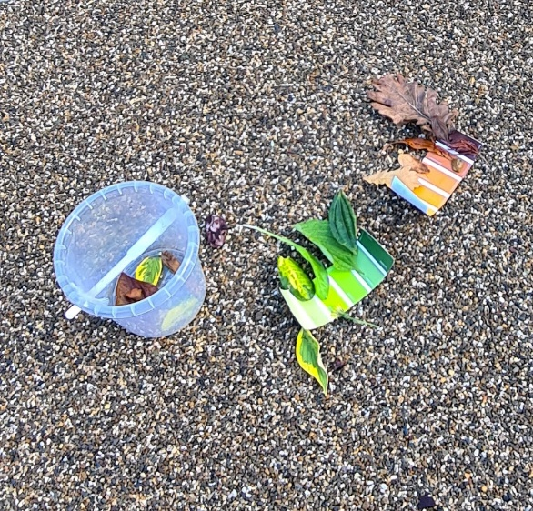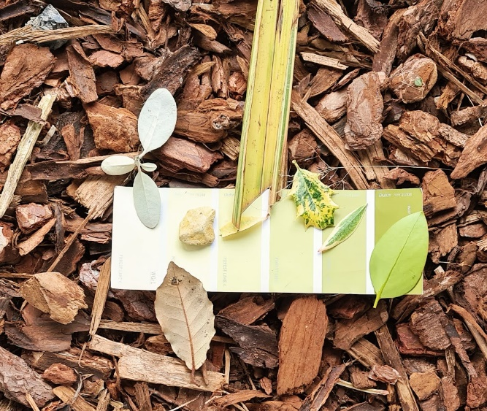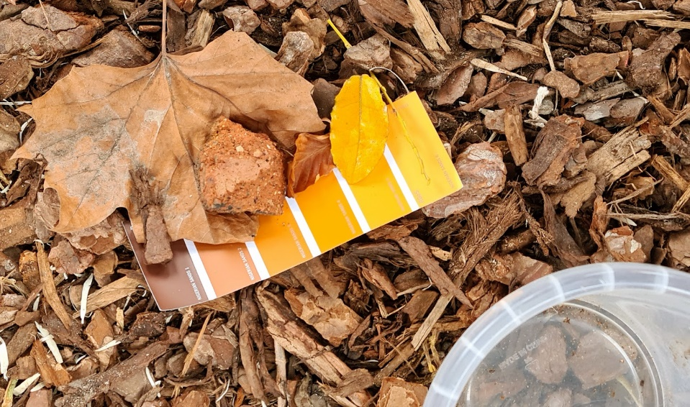

Key Questions:

- Where did you find the materials?
- Why did you choose that particular material?
- Were there any other objects that could have matched that colour?
- Are the materials natural or manmade?
Extension tasks:

- Ask the chn to join with other pairs/groups to make a colour gradient with all their materials.

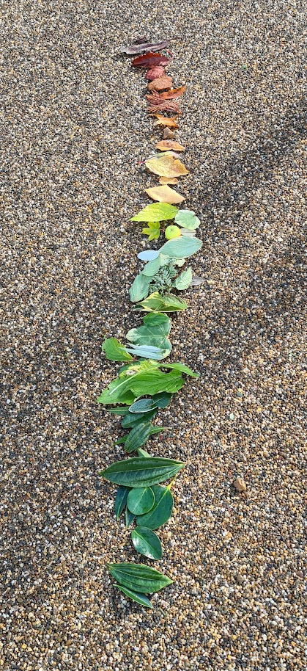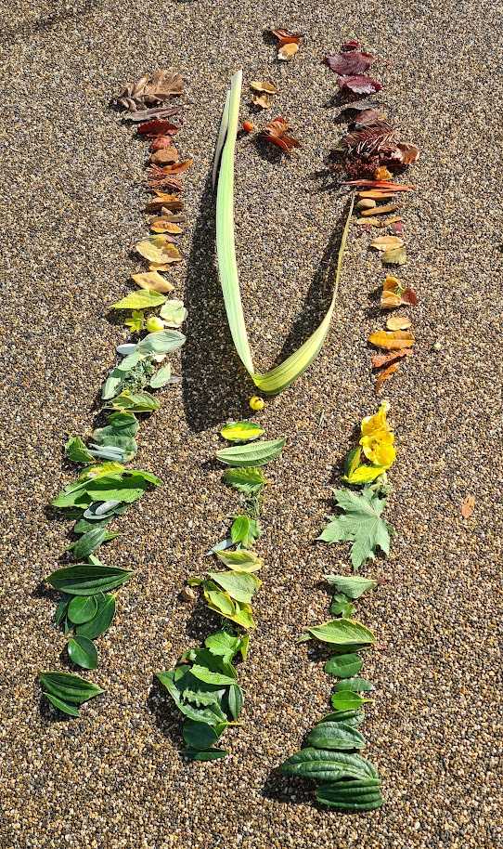

- Play a game of ‘I went to outdoor space/forest school/field and found a…’ using the objects in their buckets. Pupils sit in a circle with their buckets of found objects:
  - The first child will begin choosing an item from their bucket and holding it up to show the others. They will start the game by saying “I went to the outdoor area and found a green leaf.”
  - The child to the left will repeat what the first child said and add 1 more item from their bucket. For example, “I went to the outdoor area and found a green leaf and a yellow flower.”
  - The next child will carry on by saying, for example, “I went to the outdoor area and found a green leaf, a yellow flower and a scratchy sticky.”
  - Carry on adding 1 item per child, until you are back to the first child. The first child then repeats the entire list one final time.
  - To increase the difficultly level, the children can use cumulative adjectives to describe their object.
- Sort materials using hoops for Venn diagrams eg texture (hard/soft/smooth/etc); natural or manmade; colour; shape; size.

Activity 3: Make a piece of natural art

Aim: To introduce the children to using natural materials; help them to discover textures, smells and colours of natural materials; encourage use of imagination.
Ask the children to find the following from around the Thrive in the Forest area to use with grass reed frames to assemble their pictures:
Leaves
Twigs
Mud
Pebbles
Grass
Instructions for assembling:
Children to use the grass reed frames to make their own piece of natural artwork from collections of materials found in the Thrive in the Forest area.
Key questions:
Did I find appropriate materials for my picture?
Did I make sure I only took plants from the ground?
What natural materials did I use?
Did I use any man-made materials? Why did I choose them over natural materials?
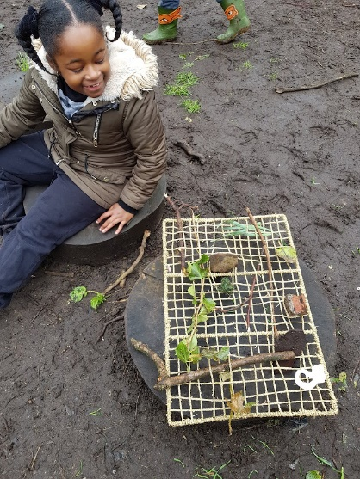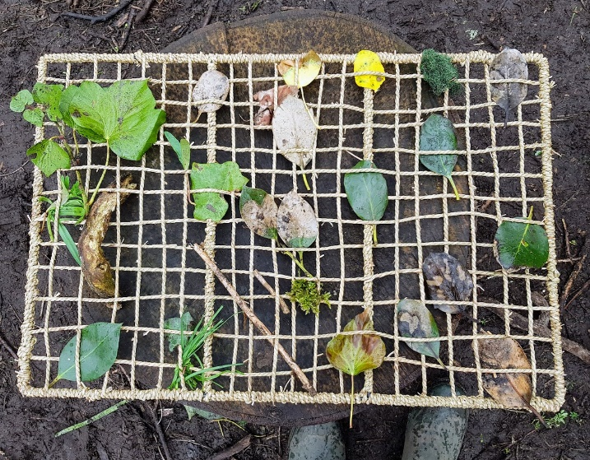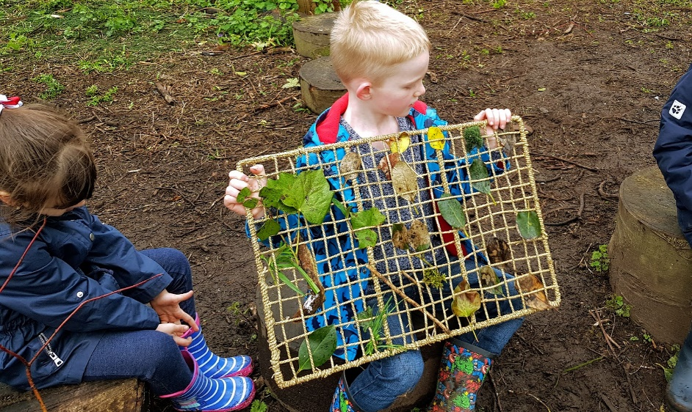

Activity 4 – Scavengers

Aim: Students are to use materials from the natural environment to physically portray a key moment from today’s session (I.e., students may use something they created or found in the session and share why they selected it and how it relates to the session).

Send students out in search of an object that mirrors the most important thing they learned during the day.
Have each student share their story in partners, then give an opportunity to share within the group.
The object removes the focus off the individual and directs it to the object making it easier to communicate

Key questions that can be used to encourage conversation:

- What have you enjoyed today?
- Did you learn anything new?
- What made you laugh the most?
- What surprised you?
- What sounds can you hear around you?

Activity 5 – Making hot chocolate and toasted marshmallows.

Children need to demonstrate an awareness of fire safety at all times by following the demonstrated procedures and moving in a safe manner around the fire.
- Find a stick to use for marshmallows.
- Do not cross the fire circle – always walk around the fire pit with care.
- Marshmallows need to be toasted by holding the stick at the far end.
- Avoid letting fingers touch the hot part of the stick.
- Wait for the marshmallow to cool slightly before touching (count to 10).
- Children to kneel with one leg up to support them when toasting marshmallows.

All children will be closely monitored by adults when they are around the fire pit.

Resources: cotton wool, fire steels, kindling, wood, fire pit, marshmallows, chocolate digestives, plastic cups, water (for hot chocolate and enough to put out fire in an emergency and at the end of the session). Emergency Fire Safety Kit will be situated near the fire pit in case of emergency.

Children’s Activity (Holistic learning and development):  - Development of gross and fine motor skills.  - Language development.  - Confidence skills.  - Wellbeing.  - Behaviour.  - Social interaction/group work. |  | AFL:  - Teacher assessment of activities (ongoing).  - Self-assessment – reflection time.  - Make a natural picture – What do we need to use to make a natural picture? Self and peer assessment
Differentiation/Inclusion:
Children will work in pairs and will be guided by an adult (either teachers or TAs) for the Colour swatch activity to ensure that they are scaffolded to aid with language skills and develop cooperation skills. The natural art activity will be done individually but under supervision of staff.
Children’s Self-esteem/Independence skills:
I can:
- Work with others
- Find different objects in the Thrive in the Forest
- Identify a range of materials to make a natural picture.
- Spend time in quiet reflection.

Links to theories (tick as appropriate):
- Social constructivism (Vygotsky)
- Concrete Operational Stage (Piaget)
- Schema (Piaget) including:
  - Transporting – carrying/organising/moving materials, collecting wood to work with.
  - Rotation – walking around the fire circle, moving materials around the frame.
  - Enveloping –hunt for materials, making s’mores sandwiches.
  - Boundary – crossing either physically or with objects.
  - Connection – collecting materials, attaching materials to the frame, combining materials with string, wrapping objects together.
  - Trajectory – whittle wood for toasting marshmallows, giving out food.

